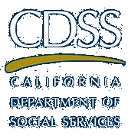
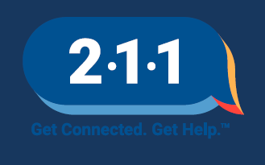
ATTENTION CALIFORNIANS

Do you need help covering everyday expenses since Coronavirus?

You may be entitled to a tax-free Economic Impact Payment
These payments do not impact CalWORKs or CalFresh eligibility or benefits!

- $1200….. Per Eligible Adult
- $2400….. Per Married Couple
- $500…… Per Eligible Minor

Dial 2-1-1 to get connected with local tax prep resources!

