Coronavirus Aid, Relief, and Economic Security (CARES) Act
Economic Impact Payment Guide for Californians

What are Economic Impact Payments?
Economic Impact Payments (EIPs) are payments issued by the federal government to help reduce financial burdens caused by the COVID-19 pandemic
- The EIP does not count as earned income and will not affect eligibility for programs like CalFresh and CalWORKS.
- The EIP does not have to be repaid.
- The EIP is not taxable income.

Economic Impact Payments
$1,200 ….. Per Eligible Adult
$2,400…... Per Married Couple
$500…...... Per Eligible Minor

Who is eligible?
U.S. citizens, permanent residents and qualifying resident aliens who:
- Have a valid Social Security number,
- Cannot be claimed as a dependent of another taxpayer, and
- Had adjusted gross income under $99,000 for a single taxpayer and under
$198,000 for married couple.

How is payment received?
Residents of California may:
- File their 2018 or 2019 federal income tax return to receive the payment, or
- Use the IRS Non-Filer Info Tool if income is less than $12,200 ($24,400 for a married couple)

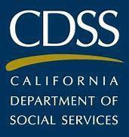
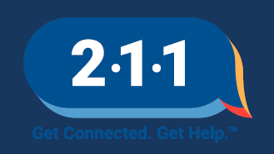
IN PARTNERSHIP

Where can taxes be filed?
- If you didn’t file your 2018 or 2019 federal income tax return AND your gross income was under $12,200 ($24,400 for married couples), you can now use the IRS Non-Filers: Enter Payment Info Here tool. Visit Payment Information Tool
- Tax filing can be done using many sources like the IRS Free File. Visit Free Filing Online IT’S FREE!
- Free, local tax return preparation referrals are available by calling 2-1-1.

When do taxes need to be filed?
- Income tax deadlines have been extended to July 15, 2020. For the latest info, check with the IRS at irs.gov and California Franchise Tax Board (FTB) at ftb.ca.gov.
- The deadline for submitting a request for EIP via the Non-Filer Tool is October 15, 2020. Anyone who is eligible to use the Non-Filer tool but who misses the October 15 deadline may file their 2020 federal return to receive the EIP as a tax credit.
- Free, local tax return preparation referrals are available by calling 2-1-1.

How to get help:
  - Dial 2-1-1, where you will be walked through a series of questions and referred to additional resources for filing your income taxes.
  - For more information about Economic Impact Payments, visit the CDSS Economic Impact Payment Information and Resources Hub.
  - If you have already filed you 2018 or 2019 income taxes or submitted for your EIP using the Non-Filer Tool, check the status of your payment by visiting the IRS Get My Payment webpage at IRS Get My Payment
  - For frequently asked questions about your tax refund, visit the Get My Payment Frequently Asked Questions webpage at IRS Payment Frequently Asked Questions questions.

