744 P Street, Sacramento, CA 95814 www.cdss.ca.gov

August 30, 2012

SUBJECT: CASE MANAGEMENT INFORMATION AND PAYROLLING SYSTEM II (CMIPS II) DESK REFERENCE

BACKGROUND

The attached document is the most updated version of the CMIPS II Desk Reference available. It is a supplemental aid covering additional topics from the CMIPS II manual and training materials. Please consult this document prior to contacting the California Department of Social Services or HP CMIPS II Help Desk for assistance.

Sincerely,

The California Department of Social Services

Note:
Information provided herein are frequently encountered topics or complex topics encountered by the prior go-live group(s) to assist in managing caseloads or providers in CMIPS II. Topics herein are subject to change.

The CMIPS II Desk Reference supplements existing county/state training materials or job aids.

Document Control
Version | Release Date
1.0 | 01/17/2013
1.1 | 02/20/2013
2.0 | 04/12/2013
2.1 | 04/15/2013
3.0 | 08/23/2013  Note:  - Removed Medi-Cal Terminates IHSS Case. For instructions, reference the HP CMIPS II Informational Notification for Understanding Share of Cost Evidence.  - Removed Inter-County Transfers from CMIPS II Desk Reference. For instructions, reference the new Inter-County Transfer Job Aid sent 08/15/2013.  - Removed Recipient Waiver Exists and Provider Cannot Be Assigned to the Case from CMIPS II Desk Reference. For instructions, reference the Manage CORI Record Job Aid sent 08/15/2013.  - Removed Notify CDSS County Help Line: State Hearing Outcome Requires Payment Prior To Application Date. NEW CDSS Direction: Counties do NOT notify CDSS of these ALJ decisions.
Table of Contents

Case Management 6
IHSS Service Types 7
CDSS Direction – Instructions on Backdating Excluding State Hearing Outcome 9
Delete or Modify Converted Time On A Converted Case 11
Deleting Time (HH:MM) On A Converted Case 11
Modify Converted Time (HH:MM) On A Converted Case 12
Rounding Issues From Legacy To CMIPS II On Converted Cases 13
Recommend: Using A Free-Form Task To Update A Multiple Service Type 13
Updating Other Service Types (Predefined or Single Service Types) 14
18 Month Renewals 15
Case Event: Recipient Turns 18 16
Case Event: Child Turns 14 16
NOA Messages 17
Deny For No Healthcare Certification 17
Deny For No Assessed Need 17
Deny For Whereabouts Unknown 17
Terminate For No Healthcare Certification 18
Terminate for Recipient Death 18
Unable To Terminate Case: Error Message About Functional Ranks Displays 19
Error Message Displays When Terminating From Case Home 19
Error Message Displays When Processing Check Eligibility 19
Information Only: Unable To Rescind A Legacy Terminated Case In CMIPS II 20
Check Eligibility Outcome Does Not Match My Expected Outcome 21
Check Eligibility: No Medi-Cal Eligibility Found 22
Understanding How CMIPS II Activates Evidence 23
Timely Notice Required When Total Authorized To Purchase Hours Increased 24
Timely Notice Not Required When FFP Change From PCSP To IPO 25
Supervisor Review Checklist 26
Provider Management 27
Understanding Provider’s Effective Date and Recipient’s Authorization End Date 28
Authorization End Date of Case Leave or Termination 28
Effective Date of Provider’s Leave or Termination 29
Assign Provider To A Case Retroactively 30
Assign a New Provider to the Case Retroactively 30
Reinstate a Previously Assigned Provider Retroactively 31
Understanding Assigned Hours 32
SOC 838 On File: Assign Provider To Case 32
SOC 838 On File: Reinstate Provider From Leave/Terminate Mid-Month 32
Without SOC 838: Assign New Provider To Case 34
Without SOC 838: Reinstate Provider From Leave /Terminate Mid-Month 34
Flag A Timesheet For Review 34
Timesheet & Payroll Management 35
Where’s My Timesheet: Understanding Timesheet Status 36
Where’s My Check: Understanding Payment Details 37
Life Cycle of A Timesheet 38
Unable To Issue A Timesheet For A Provider 39
Generation of Next Arrears Timesheet vs Voided Timesheet 39
Unable To Reissue A Payment That Was Voided In Legacy 40
Rebuild Provider Segments Retroactively 41
Overpayment Overview 42
Create Overpayment Occurrence-Excess Compensation Hours 43
Create Overpayment Occurrence-Legacy Special Transaction 46
Overpayment from Legacy Cannot be established in CMIPS II 47
Overpayment Collections through Journal Voucher Adjustment (JVA) process flow 48
Recording Overpayment On Legacy Case or Provider Record Not Converted 49
Special Transaction-State Hearing: Authorize Pay Prior To Application Date 50
Special Transaction for State Hearing 50
Reports: Functionality Clarification 51
Reports In County Folder 52
Monthly Assessment Due Report 55
Monthly Caseload, Hours Paid and Expenditures - Total 56
Overdue Assessment Report 57
Provider Payment Summary Report and Detail Report 58
Provider Payment Detail Report 58
Timesheet Exception Report 59
Other Information 61
How To Multi-Task Within Case Management 62
To Get Rid Of Security Warning Pop-Up Window 63

Case Management

IHSS Service Types

Service Type | Weekly or Monthly | Task Frequencies | Proration (Y/N) | Tasks  Single, Predefined  or Free-form
Domestic Services | M | Daily  Weekly  Monthly | Y | Single  Number of rooms may not exceed 10
- Preparation of Meals | W | Daily  Weekly | Y | Predefined with a maximum of 7 tasks:  - Breakfast  - Lunch  - Dinner  - Snack
** Meal Clean-up | W | Daily  Weekly | Y | Predefined with a maximum of 7 tasks  - Breakfast  - Lunch  - Dinner  - Snack
Laundry | W | Daily  Weekly | Y | Single
Shopping for Food | W | Daily  Weekly | Y | Single
Other Shopping & Errands | W | Daily  Weekly | Y | Single
- Respiration | W | Daily  Weekly | N | Single
- Bowel & Bladder Care | W | Daily  Weekly | N | Freeform with a maximum of 3 tasks
- Feeding | W | Daily  Weekly | N | Freeform with a maximum of 3 tasks
- Routine Bed Baths | W | Daily  Weekly | N | Single
- Dressing | W | Daily  Weekly | N | Freeform with a maximum of 2 tasks
- Menstrual Care | W | Daily  Weekly | N | Single
- Ambulation | W | Daily  Weekly | N | Single
- Transfer | W | Daily  Weekly | N | Single
- Bathing, Oral Hygiene, Grooming | W | Daily  Weekly | N | Freeform with a maximum of 6 tasks
- Rubbing Skin, Repositioning | W | Daily  Weekly | N | Predefined with a maximum of 3 tasks:  - Range of Motion  - Repositioning  - Rubbing of Skin
- Care and Assistance with Prosthesis | W | Daily  Weekly | N | Predefined with a maximum of 3 tasks:  - Care and Assistance with Prosthesis  - Medication Set-up
Accompaniment to Medical Appointments | W | Daily  Weekly | N | Freeform with a maximum of 3 tasks
Accompaniment to Alternative Resources | W | Daily  Weekly | N | Freeform with a maximum of 2 tasks
Protective Supervision | W | N/A | N | NA-calculated by system
- Paramedical Services | W | N/A | N | NA-totals are entered
Heavy Cleaning  - 1 mos | M | Daily  Weekly  Monthly | Y | Single
Yard Hazard Abatement  - 1 mos | M | Daily  Weekly  Monthly | Y | Single
Removal of Snow, Ice  - 1 mos | M | Daily  Weekly  Monthly | Y | Single
Teaching & Demonstration  - up to 3 mos | M | Daily  Weekly  Monthly | Y | Single
- Time limited services are subject to an authorization limitation as identified. To end time limited services, no action is necessary by the user. To continue time limited services, create a change assessment.
- Non-Severely Impaired (NSI) when the “Individual Assessed Need” for Service Types (*) is less than 20 hours per week
** Meal Clean-up: Include in NSI determination if Preparation of Meals and Feeding have assessed need

CDSS Direction – Instructions on Backdating Excluding State Hearing Outcome

CMIPS II design only allows a user to backdate an application for 14 days. Per ACL 12-35, once a county implements CMIPS II they should be entering applications directly into CMIPS II as soon as they are received. Due to the increased workload of preparing for CMIPS II implementation and limitations with converted cases, CDSS acknowledges there may be some applications that were not entered into the system on time and/or cases that were denied or terminated in Legacy CMIPS that are unable to be reactivated in CMIPS II. To assist counties through this conversion period, CDSS has come up with a process to pay providers with a CDSS only SPEC transaction for the time period that the application date cannot be back-dated.

To process the SPEC transaction for these cases counties will need to submit the following information by email to CMIPSII-Requests@dss.ca.gov:

- The email needs to include a detailed explanation of why the SPEC transaction is needed.

- A timesheet for each pay period that records the hours to be paid, signed by both the recipient and provider. This does not have to be a CMIPS II timesheet, it can be a county created form but must include the recipient’s name, case number, provider name, provider number, authorized hours, and a grid for the provider to record the time they worked by day. The amount claimed on the timesheet must match all other documentation, including the authorized hours for the period. (I have attached a sample of the timesheet that San Diego created, IHSS Special Transaction Time Sheet form.)

- A spreadsheet that lists by month the total number of authorized hours, the number of hours the provider has already been paid for in that month, the number of hours to be paid by CDSS and the amount you calculated (hours * county wage). CDSS will not process any SPEC transaction where the hours on the timesheets do not match the hours being claimed on the spreadsheet.

Here is a sample:

Month | Authorized Hours | Hours Already Paid | Hours to Be Paid on SPEC | County Wage Rate | Amount
March 2013 | 100 | 20 | 80 | 8.00 | $640.00

4) The county should appoint a point of contact to review and approve all requests, but at a minimum a supervisor in the county must review the SPEC request prior to it being sent to CDSS and must be included in CC: line on the email. CDSS will not process any SPECs without a county supervisor approval.

Note: The counties should enter the application ASAP and should backdate the case as far back as the system allows prior to sending a SPEC request. Additionally, CDSS cannot process SPEC transactions for cases where the recipient did not submit their Healthcare Certification to the county.

If a case was denied or terminated for no healthcare certification then the recipient should request a state hearing when they receive their NOA. If an ALJ finds in favor of the recipient then the county should backdate the case as far as they can in CMIPS II and issue a State Hearing Payment SPEC transaction for the period the application cannot be backdated. For additional information, refer to Special Transaction-State Hearing: Authorize Pay Prior To Application Date section.

IHSS SPECIAL TRANSACTION TIME SHEET.
RECIPIENT NUMBER : PROVIDER NUMBER:

Last Name |  | First | Ml | Last Name |  | First | MI
Address |  |  |  | Address
City | State | Zip | Address Change | City | State | Zip | Address Change

You are authorized: Hours for the Month of:

Days | 1 | 2 | 3 | 4 | 5 | 6 | 7 | 8 | 9 | 10 | 11 | 12 | 13 | 14 | 15
Hours/Min

FILL IN HOURS FOR EACH DAY WORKED AND PLACE TOTAL HOURS HERE (LLENE LAS HORAS TRABAJADAS CADA DIA Y APUNTE EL TOTAL AQUI)
WE AFFIRM THAT THIS TIMESHEET IS A TRUE AND CORRECT STATEMENT OF TIME WORKED THE IHSS PROGRAM AND THE SHARE OF COST LIABILITY ________ FOR THE PERIOD HAS BEEN MET (SIGN ONLY AFTER WORK HAS BEEN COMPLETED).
AFIRMAMOS QUE ESTE 1-IORARJO ES CUENTA CORRECTA DE 1-IORAS TRABAJADAS BAJO EL PROGRAMA DE II-ISS Y QUE LA PARTE DEL COSTO QUE PAGAMOS NOSOTROS POR ESTE PERIODO Y A ESTA PAGADA (FIRME SOLAMENTE CUANDO EL TRABAJO ESTE COMPLETADO).RECIPIENT SIGNATURE: DATE: PROVIDER SIGNATURE: DATE:

X X ____________________________________
SIGN AND MAIL TIME SHEET TO THIS ADDRESS:
___________________________________________________________________________________________________________________
IHSS SPECIAL TRANSACTION TIME SHEET.

RECIPIENT NUMBER : PROVIDER NUMBER:

Last Name |  | First | Ml | Last Name |  | First | MI
Address |  |  |  | Address
City | State | Zip | Address Change | City | State | Zip | Address Change

You are authorized: Hours for the Month of:
Days | 16 | 17 | 18 | 19 | 20 | 21 | 22 | 23 | 24 | 25 | 26 | 27 | 28 | 29 | 30 | 31
Hours/Min

FILL IN HOURS FOR EACH DAY WORKED AND PLACE TOTAL HOURS HERE (LLENE LAS HORAS TRABAJADAS CADA DIA Y APUNTE EL TOTAL AQUI)
WE AFFIRM THAT THIS TIMESHEET IS A TRUE AND CORRECT STATEMENT OF TIME WORKED THE IHSS PROGRAM AND THE SHARE OF COST LIABILITY ________ FOR THE PERIOD HAS BEEN MET (SIGN ONLY AFTER WORK HAS BEEN COMPLETED).
AFIRMAMOS QUE ESTE 1-IORARJO ES CUENTA CORRECTA DE 1-IORAS TRABAJADAS BAJO EL PROGRAMA DE II-ISS Y QUE LA PARTE DEL COSTO QUE PAGAMOS NOSOTROS POR ESTE PERIODO Y A ESTA PAGADA (FIRME SOLAMENTE CUANDO EL TRABAJO ESTE COMPLETADO).RECIPIENT SIGNATURE: DATE: PROVIDER SIGNATURE: DATE:

X X ____________________________________
SIGN AND MAIL TIME SHEET TO THIS ADDRESS:

Delete or Modify Converted Time On A Converted Case

When managing your converted case, it is important to remember CMIPS II collects more case information than Legacy. This collection includes, but not limited to, data on frequency, duration and proration for assessed service tasks on each service type. This desk reference provides instructions for deleting or modifying the converted service hours in CMIPS II.

Deleting Time (HH:MM) On A Converted Case
- Create pending evidence by selecting Add new evidence. Then, select the applicable assessment type.

- From the Service Evidence screen, select “Edit” to create a new service task for the converted service type.
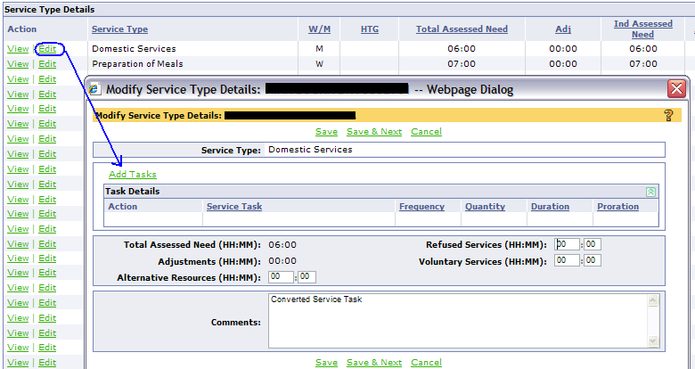

HELPFUL HINT: The purpose for creating a new task for the converted service type is to trigger the system into displaying the “delete” option. As a result, it is not necessary to ensure both the HH:MM reflected on the new service task match the converted service type.

- From the Modify Service Type screen, delete the service task.
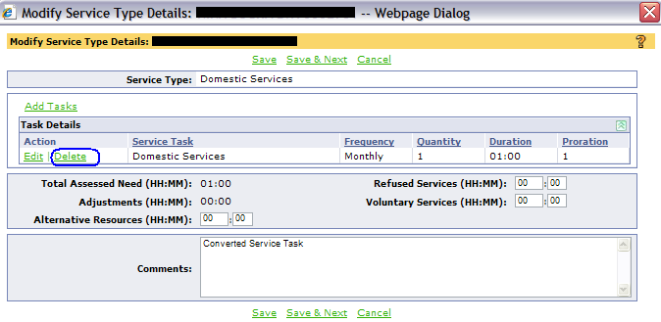
HELPFUL HINT: DO NOT delete text in the comment field. If the newly entered HH:MM is outside the HTG range, this text allows system to recognize the documentation exists and saves the (updated) HH:MM.
HELPFUL HINT: If HTG error message “Assessed Need required when Functional Rank is greater than 2.” displays, select Cancel. CMIPS II will still save the newly entered HH:MM.

- From Service Evidence, update existing FI rank to 1 for the service type.

- Optional: From Service Evidence, delete the text in the comment field if appropriate.

- When all converted service types are deleted, complete remaining evidence. Process check eligibility then Submit for Approval.

Modify Converted Time (HH:MM) On A Converted Case

- From the Evidence Home screen, select Add New Evidence link. Then, select the applicable assessment type.

- From Service Evidence screen, select Edit Functional Ranks hyperlink to update FI ranks for applicable service types.

- From the Service Evidence screen, select the Edit link to create a new service task for the converted service type.

- From the Create Task Details screen, enter the frequency, quantity, duration and proration. When applicable, enter the new service task. Then, select Save.

- From the Modify Service Type screen, document the HTG exception in the comment field when applicable. Then, select save.

- If multiple service types require updating, repeat steps 3-5. Then, complete remaining evidence.

- Process check eligibility then Submit for Approval.

Rounding Issues From Legacy To CMIPS II On Converted Cases
When check eligibility is processed on the first assessment after conversion, the time is converted from Legacy to CMIPS II and the Authorized to Purchase (ATP) time is recalculated. If there is no change to the converted Legacy time, this process will result in three possible outcomes. CDSS has provided direction only to outcome 2. This desk reference will provide instructions for updating the monthly or weekly service types for outcome 2.
Outcome 1) CMIPS II Authorized to Purchase (ATP) matches exactly to the Legacy ATP.
When this occurs, no action is necessary by the user

Outcome 2) CMIPS II ATP is less than the Legacy ATP.
During Check Eligibility process, the error message displays "Total Auth to Purchase is decreased by [XX:XX] due to conversion of Legacy hours to CMIPS II hours and minutes. Please increase a Monthly Service Type by [XX:XX] or a Weekly Service by [XX:XX] as directed by CDSS in the ACL providing direction regarding Conversion to Hours and Minutes.". User will add the indicated number of minutes to a service to authorize the case.

Outcome 3) CMIPS II ATP is greater than the Legacy ATP.
When this occurs, no action is necessary by the user. There will not be an informational message indicating the increase nor will there be a NOA message explaining this increase.

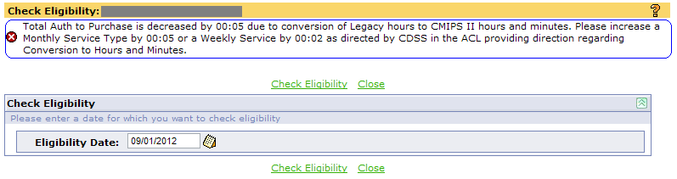
Note: Upon further evaluation by CDSS, an ACL will not be issued addressing this error message. This message only displays under the conditions specified above and the incident will occur once. As a result, this error message will not be updated and counties should refer to project handouts for direction regarding conversion to hours and minutes.

Recommend: Using A Free-Form Task To Update A Multiple Service Type
- Identify if one of the below service types is assessed for the case. These service types allow for the creation of free-form tasks.
Service Types
- Bowel and Bladder Care
- Feeding
- Dressing
- Bathing, Oral Hygiene & Grooming
- Accompaniment to Medical Appointments
- Accompaniment to Alternative Resources

- Select the service type identified, create two (2) new service tasks as follow:
  - Service task 1: This task will reflect the converted assessed hours and service name.
  - Service task 2: This task will reflect the adjustment required in the above error message. Use the following information to create this task.

Field Name | Data to Enter
Service Task 2 | Conversion from decimals to minutes
Frequency | Weekly
Quantity | 1
Duration | enter the time (HH:MM) identified in the error message

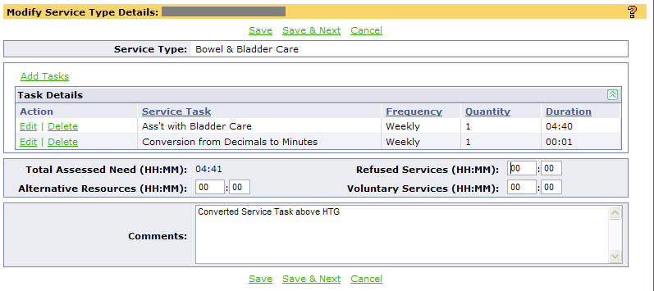
- Process Check Eligibility then submit pending evidence for approval.

Updating Other Service Types (Predefined or Single Service Types)
- Identify the service type is assessed for the case. These service types do not allow for the creation of free-form tasks. Refer to IHSS Service Types section to the appropriate predefined or single services type.
- Once you have identified the service type, select the Edit link associated with the service type.

- If a monthly service type is selected, from the Modify Service Type Details screen, select Add Task link to create a task. From the Create Task Details screen, update fields as applicable. The minute entered must include the converted assessed time and the minute required from this error message.

If a weekly service type is selected, from the Modify Service Type Details screen, select Add Task link to create a task. From the Create Task Details screen, update the fields as applicable.

- Process check eligibility and submit for approval.

18 Month Renewals

CMIPS II supports eighteen (18) month assessment eligibility. The Potential Variable Assessment Eligibility Report lists cases that have been pre-screened by the CMIP S II defined criteria. For converted cases, all of the below criteria must be met in CMIPS II (not Legacy) in order to be listed on the report.
- Not first annual reassessment
- No provider change in last 6 months
- No leave status in last 3 months
- No change in assessed hours in last 24 months
- Living arrangement has not changed since last reassessment
- Not IPO

The report lists case for the requested month and one future month. These pre-screened cases should be evaluated to ensure compliance with any county specific criteria.

The county version of this report is generated automatically as part of the Monthly batch process. Once generated, counties may view this report by accessing their own county specific folder located in the ‘County’ folder within Public Folders.

Counties may also continue to scheduling their own report. This report requires date parameters. When scheduling, do not use the automated recurring features in Reporting. Refer to your CMIPS II training material, Module 14, Schedule a Report in Advance section to schedule this report individually.

What to Do

Extending the reassessment due date in CMIPS II
- Create pending evidence
Field Name | Data Entry
Assessment Type | Reassessment

Note: Using an assessment type other than Reassessment will not update the Re-assessment Due Date from a 12-month to 18-month renewal which may result in the case being listed on the Overdue Assessment Listing report.

- From Program Evidence screen, update the following fields only:
Field Name | Data Entry
Authorization Start Date | Enter current date
Authorization End Date | Enter last day of new reassessment month (18 months)
Home Visit Date | Re-enter the last HV date
Re-Assessment Due Date | Enter new date which is 6 months after the prior Reassessment Due Date
Medical Certification Date | No change
Medical Certification Reason | No change
Presumptive Eligibility | No change
Waiver Program | Select as appropriate

- Process Check Eligibility. Then, submit for approval.

Case Event: Recipient Turns 18
When a minor recipient approaches 18 years old, the system produces a task to the Case Owner on the first of the month prior to the month in which the recipient turns 18 years old. This allows the case owner time to evaluate the case and determine the appropriate action. The task is subject to the standard 5-business day escalation deadline.
  - Task: [case name] [case number] Recipient turns eighteen (18)
Once the task is generated, two types of action may occur:
- Case Owner action: Upon reviewing the task, the case owner should evaluate age appropriate services. Then, the case owner should create a change assessment to update the service tasks with an authorization start date on the month the recipient turns 18 ensuring timely notice is provided when applicable. If the case owner determines no action is necessary, the task can be closed manually with a comment.
- System action: At the end of the month prior to the Recipient turning 18, the system updates the case as follows:
- Change the provider’s “Relationship to Recipient” record from “Parent of minor child” to “Parent of an Adult Child” if applicable
- Create an assessment type of Funding Source Update
- If no payments have been issued, the Authorization Start Date is set to the first day of the month in which the “Recipient Turns 18”
- If payments have been issued, the Authorization Start Date is set to the first day of the subsequent month after the “Recipient Turns 18”

Note: A Funding Source Update will not generate when the previous Funding Source is IHSS-R or PCSP. The funding source remains IHSS-R or PCSP.

Case Event: Child Turns 14

On the first day of the month in which the “child” of a recipient turns 14, the system generates a task to the Case Owner. This task is subject to the standard 5-business day escalation deadline.

  - Task: [case name] [case number] recipient’s child turned 14

The case owner evaluates services to determine if proration should be adjusted and creates a change assessment to reflect the change in proration. If the case owner determines no action is necessary, the task can be closed manually with a comment.

NOA Messages

CMIPS II supports multiple NOA codes and messages, instructions herein are limited to the denial for no healthcare certification, no assessed need and whereabouts unknown. For instructions on generating other NOA messages, refer to the Notice of Action (NOA) Job Aid in the CMIPS II User’s Manual, Appendix A.

Deny For No Healthcare Certification

To deny a case for No Healthcare Certification the case must have the following information entered in the Pending Evidence:
- From the Cases Left Navigation select the Program Evidence screen

- When the Program Evidence screen displays scroll to the bottom of the screen and select the Add/Modify Manual NOA link

- When the Modify Manual NOA screen displays, select the checkbox for DN22, and save the screen

- Return to the Evidence Workspace, process Check Eligibility. On the Authorization Summary screen, verify the DN22 NOA message should displays in the Manual NOA field at the bottom of the screen

Deny For No Assessed Need

To deny a case for No Assessed Need the case must have the following information entered in the Pending Evidence:
- Service Evidence – Functional Ranks – All Functional Ranks must be set to 1 or 2. Any indication above 2 requires Service Type Details be completed.

- Program Evidence – Select the Edit Program Evidence screen - Once this screen is accessed all fields are required.

- Return to the Evidence Workspace – Process Check Eligibility. On the Authorization Summary screen, verify the DN05 NOA message should display in the System Generated NOA field at the bottom of the screen

Deny For Whereabouts Unknown

To deny a case for No Assessed Need the case must have the following information entered on the case:
- Person Home – Meets Residency Requirement – Set to Whereabouts Unknown
  - This same field and therefore process this will be used for other reason that displays on the Meets Residency Requirement

- Add Pending Evidence

- Process Check Eligibility. On the Authorization Summary screen, verify the DN05 NOA message should displays in the Manual NOA field at the bottom of the screen

Terminate For No Healthcare Certification

- Prior to starting, ensure all Pending Evidence has been deleted to prevent triggering the error message “Please delete this Pending Evidence before processing Leave or Terminate Case action.”
- From Case Home screen, select the Terminate hyperlink.
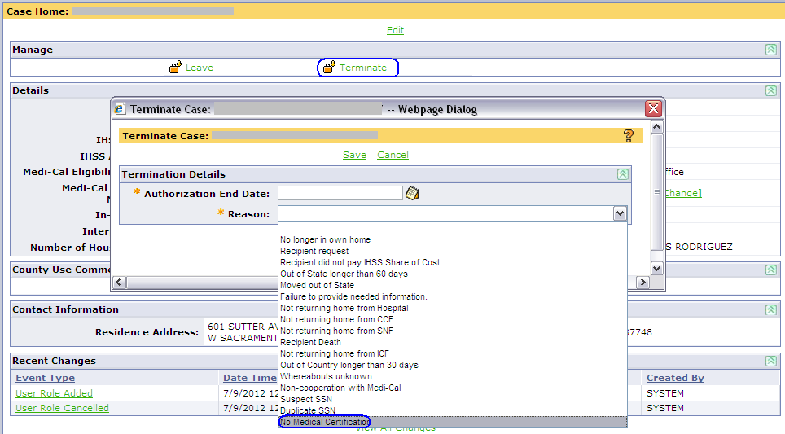
- From Terminate Case screen, complete the following fields:
  - Authorization End Date = Effective date of termination
  - Reason = No Medical Certification
Helpful Hint: Ensure Authorization End Date includes a 10-day notice.

- From the Authorization Summary screen, verify the NOA code in the system generated field reflects: TR22

Terminate for Recipient Death
To deny a case for Recipient Death the case must have the following information entered:
- Update Person Home screen, complete the fields:
  - reported date of death
  - date of death
  - death notification source
  - Death Outcome

- From Case Home, select the Terminate link

- Enter authorization end date and reason code: Recipient Death

Unable To Terminate Case: Error Message About Functional Ranks Displays

When terminating a case in CMIPS II, all the business rules run. The system will not allow a functional rank greater than 2 to have no service assigned.
What to Do

Error Message Displays When Terminating From Case Home
- Navigate to the Evidence folder to create pending evidence. Select the “Change” assessment type

- In Service Evidence, modify the functional ranks for the service tasks where the error triggered
  - Delete existing service time if there is any

- In Program Evidence, enter an Authorization Start Date and keep the Authorization End Date the same
Note: If existing service time is deleted, a timely NOA is required. The Authorization Start Date should be 13 days from the current date.

- Process Check Eligibility for the same Authorization Start date

- Check the results ensuring the system’s outcome matches your expected outcome.

- Submit for Approval.

- Once pending evidence is approved, navigate to the Case Home and execute termination using the appropriate termination reason.

- Recommend: Make sure to pull the change NOA so it does not get mailed. Then, inactivate the change NOA as “Not Mailed” on the Forms screen.

Error Message Displays When Processing Check Eligibility

- Navigate back to Service Evidence screen associated with the Pending Evidence. Then, update one of the following:
    - Update the functional rank for the specified service task where the error triggered
    - Enter appropriate service time for the specified service task where the error triggered
    - Delete existing service time for the specified service task where the error triggered

- In Program Evidence, update the Authorization Start Date as appropriate.
Note: If existing service time is deleted, a timely NOA is required. The Authorization Start Date should be 13 days from the current date.

- Process Check Eligibility again. Verify system outcome matches your expected outcome.

- Submit the pending evidence for approval.

Information Only: Unable To Rescind A Legacy Terminated Case In CMIPS II

When a case is terminated in legacy CMIPS that termination cannot be rescinded in CMIPS II. The only action can be taken in CMIPS II is to reactivate the case then back date the IHSS Referral Date two (2) weeks. For related information, refer to the CDSS Direction – Instructions on Backdating Excluding State Hearing Outcome section.

When a case is terminated in CMIPS II that termination may be rescinded in CMIPS II. When rescinding these cases, the user should verify there is no Pending Evidence on the case before the Rescind action is processed. If Pending Evidence exists, the Pending Evidence must be deleted before the Rescind action occurs.

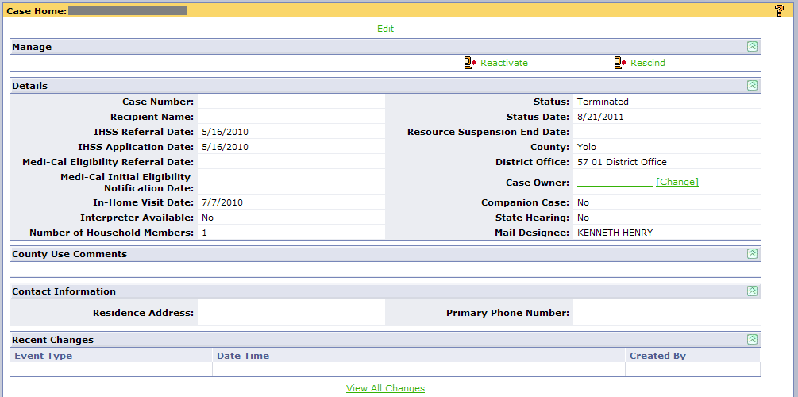

Check Eligibility Outcome Does Not Match My Expected Outcome
The Check Eligibility feature of CMIPS II is an important step in the process of submitting a case for approval. CMIPS II is processing a series of business rules and performing calculations to determine the outcome of the case (Eligible, Denial, and Termination) and the number of hours to be authorized. It is important for the worker to run Check Eligibility and review the proposed outcome of the case, including the NOA messages that will print, to confirm that this proposed outcome is in line with the worker’s expectation (i.e. CMIPS II is going to Deny the case, but the worker expected an Approval).

When the CMIP II proposed outcome does not match the worker’s expected outcome, refer to the social worker checklist as a guide in reviewing the case information and determining the resolution.

Social Worker Checklist:
- Review Pending Evidence (Household, Service, Program, Share of Cost and Disaster Preparedness)
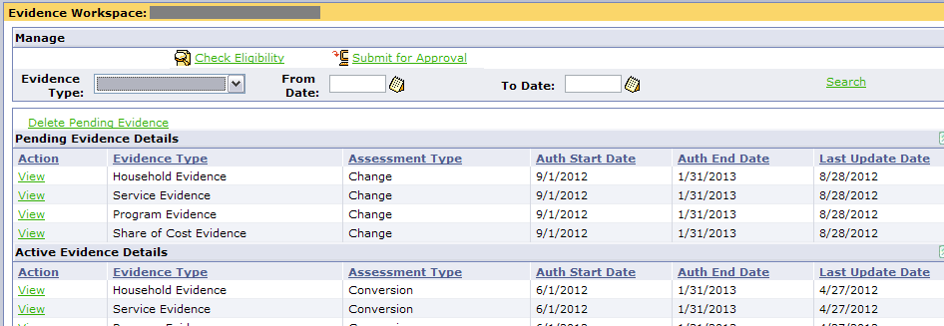
- Verify FI-ranks support service hours entered

- Verify authorization start and end dates were entered

- Verify the correct manual NOA was selected

- Verify household information and / or PS proration were set correctly

- Verify SOC linkage, benefit level and income source were entered correctly

- When determining why timely notice is required, compare the Authorization Summary of the pending evidence against the Authorization Summary of the prior active evidence. Compare the Total Need, Adjustment, Alternative Resource, Voluntary Services and/or Refused Services for each service type.

- Review Status History to verify case does not have a pending future status

- Review Case Home
- Verify district office matches the case owner’s district office

- Review Medi-Cal Eligibility
  - Verify Medi-Cal eligibility segment (FFP code, etc) is reflected for the Authorization start month

- Review Person Record
- Verify Meets Residency Requirements is set correctly
- Verify all fields related to death is appropriately updated

Check Eligibility: No Medi-Cal Eligibility Found

When a user has created an assessment in CMIPS II and runs check eligibility, CMIPS II looks for a Medi-Cal Eligibility Record for the month in which the Authorization Start Date (on Program Evidence) falls. Several conditions may result in no Medi-Cal Eligibility being found.
- For converted cases that were in “R” status in legacy CMIPS, the data in legacy CMIPS only includes the 1st month of Medi-Cal Eligibility information, the month in which the case was entered into legacy CMIPS. When the case is converted to CMIPS II, this is the only Medi-Cal Eligibility information that can be converted.
- For converted cases that were in “E” status in Legacy CMIPS, the data in legacy CMIPS does not always include all months of Medi-Cal Eligibility. When the case is converted, whatever gaps existed in legacy CMIPS will exist in CMIPS II. Following conversion, transactions are sent to MEDS to request Medi-Cal Eligibility records from the missing months. These records will be available in CMIPS II three (3) days after conversion. Check eligibility and submit for approval can be completed at that time.

Understanding How CMIPS II Activates Evidence

Before understanding the process for activating pending evidence, users should understand what is cloned into the pending evidence. The following chart specifies the information cloned for each assessment type created by the user or triggered by the system.
Assessment Type | Description
Initial | All Evidence screens are blank.
Change | Clones the most recent active evidence including the assessment narrative except the Authorization Start Date on the Program Evidence.
Reassessment | Clones the most recent active evidence including the assessment narrative except Authorization Start Date, Authorization End Date, In-Home Visit Date and Re-Assessment Due Date (Program Evidence).
Inter-County Transfer | Clones the most recent active evidence including the assessment narrative except Authorization Start Date, Authorization End Date, In-Home Visit Date and Re-Assessment Due Date (Program Evidence).
State Hearing | Clones the most recent active evidence including the assessment narrative except the Authorization Start Date on the Program Evidence.
Funding Source Update | If Pending Evidence exists, delete Pending Evidence and clones the previous assessment information including the assessment narrative except Authorization Start Date and Authorization End Date.
Cost of Living Adjustment
Wage Rate Update
State Mandated Change

When pending evidence is submitted for approval, the newly activated (pending) evidence supersedes the prior activated evidence. The system displays the assessment types in a chronological order from past, current to future according to the authorization period. Users are able to view these various assessment types along with the associated evidences and assessment narrative. From the Authorization Summary screen, the user is able to generate on demand the SOC 293 form for the associated authorization.

In situations where the pending evidence is submitted for approval and the authorization period is before or equal to the active evidence, the newly activated (pending) evidence supersedes the prior active evidence. This means the system displays the newly activated (pending) evidence and thus laying over any prior evidence created during the same authorization period as the newly activated (pending) evidence. Once replaced, users are not able to access and view the historical assessment(s) and generate on-demand the associated SOC 293 form for that assessment type. However, users are able to view and reprint the NOA generated for that prior active evidence on the Forms and Correspondence screen.

Timely Notice Required When Total Authorized To Purchase Hours Increased

Per CDSS direction, any time there is a decrease to a service task, even though there is an increased to the total authorized to purchase hours, a timely notice is required. CMIPS II supports the timely notice policy and considers any decrease in service task hours a negative action.
Example:
Prior to reassessment, the recipient is assessed a total authorized to purchase hours of 60:00 per month. At reassessment, the recipient does not require as much assistance with transferring but requires additional hours for dressing and bathing service tasks. The worker decreases existing hours for transferring and increases hours for the other service tasks. Due to the additional increased in hours, there is an overall increase to the total authorized to purchase hours from 60:00 to 63:00 per month. When Check Eligibility is processed, CMIPS II requires a timely notice to be provided (for those services for which hours were decreased).

What to Do
There are two options you have when providing a timely notice.
- From the Program Evidence screen associated with the pending evidence, modify the Authorization Start Date to include a timely notice.

OR
- Split the assessment
  - Modify the Service Evidence associated with the pending evidence to reflect only the services where hours were increased and restore services tasks where hours were decreased. Then, process Check Eligibility and ensure system outcome matches your expected outcome. Submit the pending evidence for approval.
Note: If you’re unable to determine which service task hours were decreased on the existing pending evidence, it’s best to delete that existing pending evidence then start over by creating new pending evidence.
  - Once the pending evidence for step 2a is activated, create a new pending assessment for the service(s) that decreased. From the Program Evidence, enter an Authorization Start Date to include a timely notice. Then, process Check Eligibility and ensure system outcome matches your expected outcome. Submit the pending evidence for approval.

Timely Notice Not Required When FFP Change From PCSP To IPO

When a parent provider of a minor recipient or spouse provider is assigned to the non-severely impaired case with protective supervision, CMIPS II creates a Funding source change from PCSP to IPO. This change in funding source results in a decrease in hours and does not require a 10-day notice.
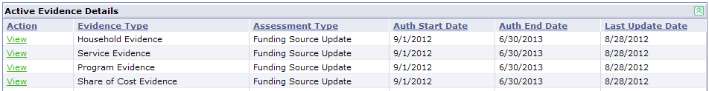
There are two reasons this funding source update does not require a 10-day notice.
- A 10-day notice is not required when the eligibility status is changed based on a statutory requirement. The 10-day notice requirements are related to eligibility for aid paid pending while the issue is heard and/or mediated. The recipient can still request a hearing, but they are not entitled to aid paid pending.
In the case of an eligibility status that determines funding source and therefore which set of program maxima applies, there is nothing for a judge to interpret. The provider is either a spouse or not, a parent of a minor child or not, or the recipient chooses to receive Advance Pay or not if they want to keep the higher hours. There are no exceptions for some kinds of spouses or some kinds of minor children or partial AP.
Though the recipient can still request a hearing, unless the hearing is based on something other than a change from PCSP to IPO, they should receive a response from State Hearings explaining changes based on state law requirements around funding sources and eligibility status are not hearable issues. As a general rule, State Hearings are to decide issues where subjective judgment is required, e.g., the recipient thinks they qualify for PS and the county doesn't think they do, or the recipient says they can't cook all their meals and the county thinks they can. Then, the judge makes a decision based on his/her interpretation of statute and regulation and testimony from both sides during the hearing.
RECOMMENDATION: Ideally, when the social worker conducts the assessment there should be some high level discussion of how the choice of a provider could affect the maximum hours the recipient could be authorized. By having this discussion, the recipient should not be surprised upon receiving the second NOA reducing their hours.
- Another consideration is whether or not payment has been made against the case. If the provider is added within a month for which payment has already been made against the case then the new Funding Source will start the first day of the next month. IHSS cases cannot have more than one Funding Source in a month.

Supervisor Review Checklist

When a user who requires supervisor approval submits a case for approval, the supervisor is given a task to review the case and either Approve or Reject the case. This task takes the supervisor to the Evidence Workspace in CMIPS II, where they can review the Pending Evidence. Simply clicking Approve doesn’t mean that CMIPS II will make the case eligible.

What to Do

When reviewing a case pending approval, the following checklist is recommended.
- Review the Evidence Workspace ensuring the Assessment Type is appropriate

- Review the Household Evidence

- Review the Service Evidence and the assessment narrative

- Review the Program Evidence

- When applicable, review the Share of Cost Evidence

- Review the Disaster Preparedness information

- Run Check Eligibility. Verify CMIPS II outcome supports the worker’s assessment. During the Check Eligibility process, a series of business rules and calculations are performed to determine the outcome of the case and the number of hours to be authorized. These outcomes may result in one of the following:
- Eligible
- Presumptive Eligible
- Denial
- Termination

Note: When determining why timely notice is required, compare the Authorization Summary of the Pending Evidence against the Authorization Summary of the prior active evidence. Compare the Total Need, Adjustment, Alternative Resource, Voluntary Services and/or Refused Services for each service type.

- Select the Approve link if the supervisor approves the outcome that has been determined for the case, based on the evidence that has been input by the worker.
- Select the Reject link if you disagree with the outcome that has been determined for the case based on the evidence that has been inputted by the worker or additional case information is missing (i.e. assessment narrative is missing, authorization start date is incorrect).

Provider Management

Understanding Provider’s Effective Date and Recipient’s Authorization End Date

CMIPS II interprets the provider’s Effective Date and the recipient’s Authorization End Date differently. To prevent confusion, it is important to understand how these dates work in relation to placing a case or provider on leave or terminate status. In summary, the authorization end date is interpreted as the ‘last day’ the provider can work for the recipient while the Effective Date is interpreted as the ‘first day’ the provider is NOT eligible to work for the recipient. Scenarios below will provide further clarification when taking these actions.

Authorization End Date of Case Leave or Termination
When placing a case on leave or terminate status, the case owner enters the last day of eligibility into the Authorization End Date field. This information tells the system the provider is eligible to claim some or all of the authorized hours on the specified ‘Authorization End Date’.

Scenario A:
Recipient was hospitalized effective 3/18 /2013.

In CMIPS II, the case owner completes the Leave Case screen as follows:
Field | User Action | Note
Authorization End Date | 3/18/2013 | If the recipient is hospitalized in the evening of this date then the provider may be eligible to claim hours in the morning or afternoon if s/he worked.
Reason | Temporarily in Hospital

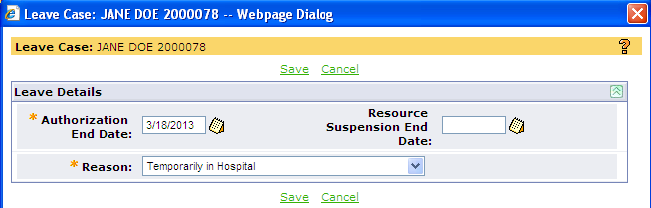

Scenario B:
During the hospital stay, it was determined the recipient will not be returning home and will be placed into a Skilled Nursing Facility permanently. The case owner is notified today, 4/1/2013.

In CMIPS II, the case owner completes the Terminate Case screen as follows:
Field | User Action | Note
Authorization End Date | 04/15/2013 | Timely notice is required for negative actions except ‘Recipient Death’.
Reason | Not returning home from Hospital.

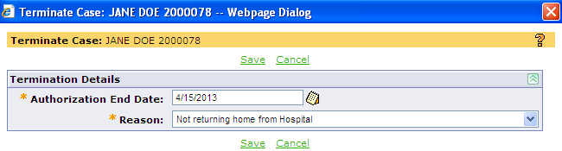

Effective Date of Provider’s Leave or Termination
In CMIPS II, when the recipient’s case is placed on Leave or Terminate status the system will automatically place the provider on leave or terminate status. However there are situations where the recipient’s case remains in Eligible status but the provider has to be placed on a leave or terminate status. When taking the leave/terminate action, the county user enters the first day the leave or terminate status will begin into the Effective Date field. This information tells the system the provider is NOT eligible to claim hours on the specified ‘Effective Date’.

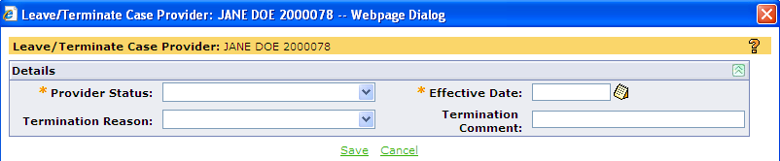

Scenario C:
Case status = Eligible
Provider is hospitalized on 5/10/2013.

In CMIPS II, the county user completes the Leave/Terminate Case Provider screen as follows:
Field | User Action | Note
Provider Status | Leave
Effective Date | 05/10/2013
Termination Reason | n/a | Leave field blank
Termination Comment | n/a | Leave field blank

Scenario D:
Case status = Eligible
Today (5/16/2013), the recipient calls to terminate the provider’s employment at the end of the month.

In CMIPS II, the county user completes the Leave/Terminate Case Provider screen as follows:
Field | User Action | Note
Provider Status | Terminated
Effective Date | 06/01/2013
Termination Reason | Recipient Requested
Termination Comment |  | optional

Assign Provider To A Case Retroactively

CMIPS II supports back payments to an eligible provider who provided services to the recipient prior to completing the enrollment process.

Note: If CORI record exists and Recipient Waiver or General Exception exists, refer to the Manage CORI Record Job Aid) sent 08/19/2013 for instructions.

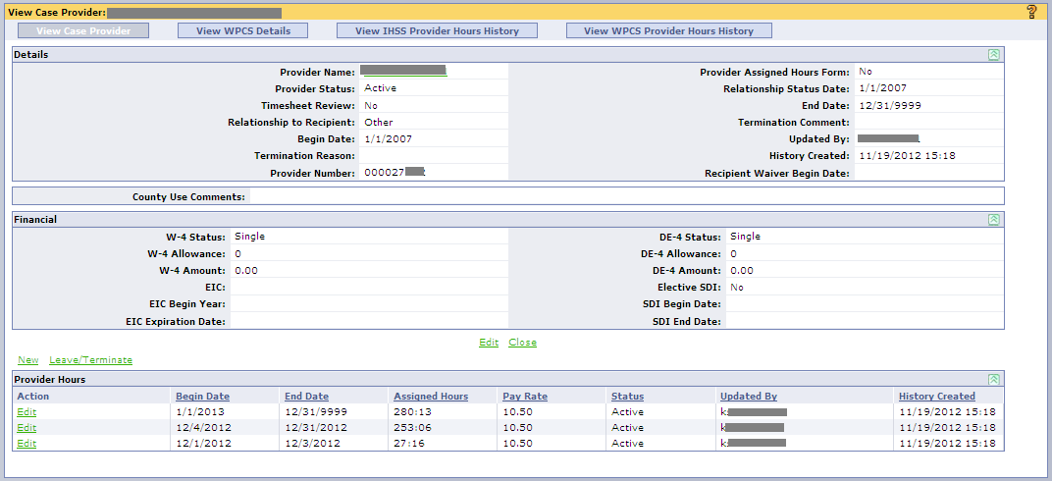

What to Do

Assign a New Provider to the Case Retroactively
- Search for the provider

- Navigate to the Provider Details screen, select Edit link and update the following field. Then, select Save link.
  - Effective Date = enter the date the provider is eligible for IHSS payment retroactively

- From My Workspace, search for the case of the recipient.

- From the Case Left Navigation menu, navigate to the Case Providers screen. Select the Assign a Provider link to assign the provider to the case.
  - Begin Date = enter the Effective Date in step 3.
  - Other fields= complete as appropriate

Reinstate a Previously Assigned Provider Retroactively

- Search for the provider

- From the Person Left Navigation menu, navigate to Provider Details screen and verify the following information:
  - Effective Date= ensure the displayed date is on or before the actual date the provider is eligible for payment retroactively

If the Effective Date is after the actual eligible date for retroactive payment, select the Edit link and update the following field. Then, select Save link.
  - Effective Date = enter the date the provider is eligible for IHSS payment retroactively

- From the Person Left Navigation menu, select Cases link. Then, select the case name link associated with the IHSS recipient who is reinstating the provider.

- From the Case Left Navigation menu, navigate to the Case Providers screen. Select the View link associated with the provider.

- From the View Case Provider screen, select the New link to create new segment to reinstate the provider. Then, select Save link.
  - Begin Date = enter the date the provider is eligible for IHSS payment retroactively
  - Other fields= complete as appropriate

Understanding Assigned Hours

Per ACL 12-55, the county/Public Authority (PA)/Non-Profit Consortium (NPC) does not have the authority to assign hours to any provider on behalf of the recipient unless requested by the recipient or the recipient’s authorized representative. This includes prorating hours to the provider when the provider starts or is terminated mid-month. The recipient or the recipient’s authorized representative may request hours to be assigned to his or her provider by completing and submitting a signed In-Home Supportive Services (IHSS) Recipient Request for Assignment of Authorized Hours to Providers form (SOC 838) to the county. Upon receipt of the signed SOC 838, the county may assign hours to the provider for the specific case in CMIPS II. Otherwise, the county should add or reinstate the provider(s) with all the recipient’s authorized hours.

If a provider/recipient relationship requires monitoring, county should request all timesheets for the provider to be reviewed prior to processing on the Assign Case Provider screen or Modify Case Provider screen. When the provider submits timesheet(s) against the recipient’s case, timesheet(s) will not be processed by TPF. It will be flagged for review and a task will be sent to the Timesheets on Hold work queue. Tasks in the Timesheets on Hold work queues are not subject to escalation, as it is required that the county take action or the system will release the timesheet for processing at the end of the next business day. Once released by either the county or the system, the timesheet will be validated against other timesheet validation business rules for errors.
The instructions below will guide counties when adding or reinstating the provider to the case with or without the signed SOC 838 form, including steps for flagging a timesheet for review.

SOC 838 On File: Assign Provider To Case
- Navigate to the Case Providers screen, select Assign a Provider link.

- From the Assign Case Provider screen, complete all required fields. In the Assigned Hours field, enter the assigned hours as indicated on the SOC 838 form and check the Provider Assigned Hours Form box to indicate this Provider/Recipient has the SOC 838 form on file. Then, select the Save link.

SOC 838 On File: Reinstate Provider From Leave/Terminate Mid-Month
To reinstate a provider from Leave/Terminate status who is assigned hours as designated by the form SOC 838:
- Prior to reinstating, navigate to the Case Providers screen and select the View link associated with the provider. Determine if there is an active segment in the month for which the provider will be reinstated.
  - If no, proceed to step 2.

  - If yes and the Provider Assigned Hours Form is not checked for that active segment, select the Edit link and complete fields below. Then, select the Save link.

Field Name | User Action
Begin Date | No change
End Date | No change
Assigned Hours | Enter the monthly designated hours as indicated on the form SOC 838.
Pay Rate | Update as appropriate
Provider Assigned Hours Form | Check this box to indicate the form SOC 838 is on file.

- From the View Case Provider screen, select the New link to reinstate the provider.

- On the Create Provider Hours screen, complete fields as follow. Then, select Save link.
Field Name | User Action
Begin Date | Enter the date the provider is returned to work.
End Date | Enter the last day of the prorated month.
Assigned Hours * | Enter the monthly designated hours as indicated on the form SOC 838.
Pay Rate | Update as appropriate
Provider Assigned Hours Form | Check this box to indicate the form SOC 838 is on file.
* Note: Assigned hours cannot exceed the recipient‘s authorized hours for the time period

- From the View Case Provider screen, create another new segment for the ongoing months.
Field Name | User Action
Begin Date | Enter the 1st day of the month in on-going segment.
End Date | Leave blank
Assigned Hours | Enter the monthly designated hours as indicated on the form SOC 838.
Pay Rate | Update as appropriate
Provider Assigned Hours Form | Check this box to indicate the form SOC 838 is on file.

OUTCOME EXAMPLE:
Provider A is assigned 10:00 hours per month by the recipient. County has SOC 838 form on file. Once the provider segments are built as instructed above, the provider segment should reflect similarly to this example:

Begin Date | End Date | Assigned Hrs | Status
6/1 | 12/31/9999 | 10:00 | Active
5/21 | 05/31 | 10:00 | Active
5/11 | 5/20 | 00:00 | On Leave
5/1 | 5/10 | 10:00 | Active

Without SOC 838: Assign New Provider To Case
- Navigate to the Case Providers screen, select Assign a Provider link.
- From the Assign Case Provider screen, complete all required fields. Then, select the Save link.

Field Name | User Action
Begin Date | Enter the date the provider returned to work.
End Date | Leave blank
Assigned Hours | Leave blank
Pay Rate | Update as appropriate
Provider Assigned Hours Form | Leave blank

Without SOC 838: Reinstate Provider From Leave /Terminate Mid-Month
To reinstate a provider who DOES NOT have assigned hours from Leave /Terminate status mid-month:
- Navigate to the View Case Provider screen to reinstate the provider by selecting the New link.
- On the Create Provider Hours screen, complete fields as follow. Then, select the Save link. CMIPS II will assign all of the recipient’s authorized hours as reflected on the Mode of Service screen to the provider.

Field Name | User Action
Begin Date | Enter the date the provider returned to work.
End Date | Leave blank
Assigned Hours | Leave blank
Pay Rate | Update as appropriate
Provider Assigned Hours Form | Leave blank

Flag A Timesheet For Review
- If assigning a new provider to the case, refer to instructions from SOC 838 On File: Assign Provider To Case. Then, proceed to Step 2.
If reinstating the provider to the case, navigate to the View Case Provider screen. Above the Provider Hours section, select the Edit link to navigate to the Modify Case Provider screen. From the modify Case Provider screen, check the Timesheet Review box to indicate timesheets for this case provider have been selected to be reviewed prior to processing. Then, select the Save link.

Note: To cancel the timesheet review request, the Timesheet Review box must be unchecked in the Modify Case Provider screen.
- When the provider submits a timesheet against the recipient’s case, it will exception out from processing and a task is sent to the Timesheets on Hold work queue. In order to process the timesheet exception efficiently, the worker should document specifically what item(s) to be reviewed on the timesheet in the County Use Comment field on the Modify Case Provider screen or in a case note.

Timesheet & Payroll Management

Where’s My Timesheet: Understanding Timesheet Status

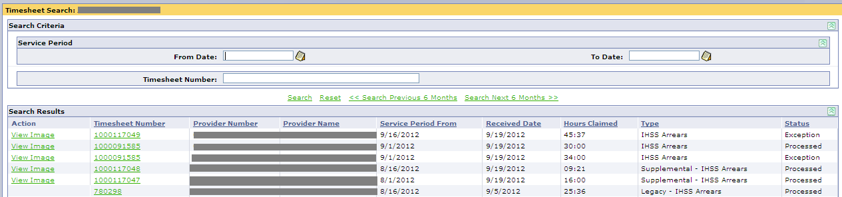
Note: All timesheets keyed manually by County staff are subject to validations and will trigger the applicable error message (hard/soft edit) to display on the Timesheet Manual Entry screen. Hard edits must be corrected before the data can be saved.

View Timesheet Screen
Timesheet Status | What does it mean?
Pending Issuance | Timesheet requested but not yet issued/printed.
Issued | Timesheet requested and printed.
Pending | Timesheet was manually keyed but not yet submitted to the nightly Payroll processing.
Processed | Timesheet received with no errors detected and has been submitted for Payroll processing.
Exception | TPF timesheet received with error detected. Timesheet is not submitted for Payroll processing.
Held – MEDS POS Error | TPF timesheet could not be process against the MEDS POS eligibility to determine the SOC deduction and is placed on a 24-hour hold.  At the end of the next business day, the TPF timesheet will be automatically released and revalidated. Another attempt will be made to process a MEDS POS eligibility transaction. If successful, the timesheet will be passed to Payroll for processing.
Held – Flagged for Review | TPF timesheet has been flagged for review on the View Case Provider screen and is placed on a 24-hour hold. At the end of the next business day, the TPF timesheet will be automatically released and revalidated but will not be subject to further hold conditions.
Held – Random Sampling | TPF timesheet is selected for signature verification. One (1%) percent of all timesheets processed by the TPF are subject to random sampling. Exception:  - WPCS timesheets  - Timesheets that were manually entered and were sent to TPF for imaging only  At the end of the next business day, the TPF timesheet will be automatically released and revalidated but will not be subject to further hold conditions.
Held – Early Submission | Timesheet received by TPF prior to the end of the pay period will be held and automatically released on the first business day of the following pay period. Exception:  - Timesheet received for a terminated provider before the end of the pay period  - Timesheet received before the end of the pay period and hours are recorded for days after the date the timesheet is received, an exception will be generated.  At the end of the next business day, the TPF timesheet will be automatically released and revalidated but will not be subject to further hold conditions.
Held – Excessive Hours Claimed | Hours claimed on the Part A timesheet exceed 70 percent of the recipient’s Total Auth to Purchase After Reduced Hours or WPCS hours. TPF timesheet is placed on hold.  At the end of the next business day, the TPF timesheet will be automatically released and revalidated but will not be subject to further hold conditions.

Where’s My Check: Understanding Payment Details

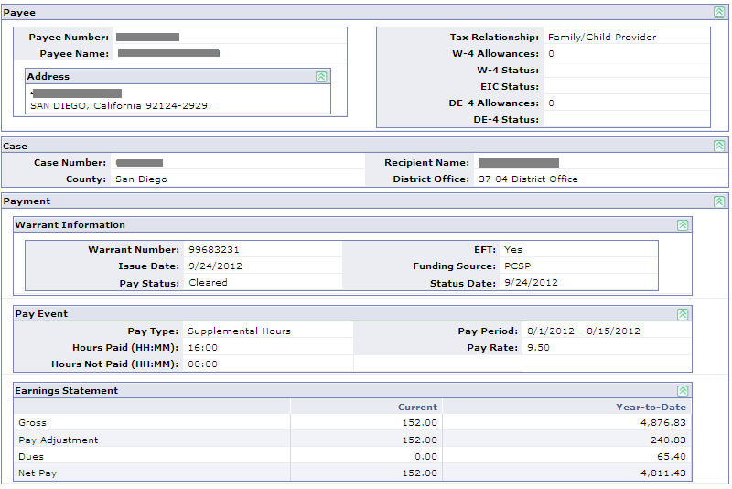
Payment Details screen
Payment Status | What does it mean?
Paid | Timesheet was successfully processed by Payroll. When confirmation is received from the State Controller’s Office (SCO), warrant number and issue date will be updated.
Cleared | Warrant was cashed.
Pending Void | A request to place a stop payment on the Paid warrant is initiated and will be listed on the Void/Stop Payment report.  When void confirmation is received from SCO:  - Pay Status is updated from Pending Void to Void, and the Status Date is updated to the void date provided by SCO.  - If applicable, a SOC reversal will be processed and Explanation of IHSS or WPCS Share of Cost Reversal letter is generated.  - If applicable, available hours will be increased by the hours paid on voided payment.
Void | Void confirmation received from SCO on the original warrant:  - Pay Status was updated from Pending Void to Void, and the Status Date was updated to the void date provided by SCO.
Pending Replacement | Pay Status will update to Pending Replacement when replacement confirmation is received from SCO:  - Pay Status is updated from Pending Replacement to Paid  - Issue and Status Dates is updated to the date provided by SCO
Field Name | What does it mean?
Warrant Number | This field will contain all zeroes until the information is returned from SCO.  Description of prefixes of warrant number:  - 70-79: Payment made in Legacy  - 80-89: Payment made in CMIPS II  - 99: EFT payment made in Legacy or CMIPS II
EFT | If Yes, the Method of Payment was through EFT.
Issue Date | Date on which the payment was issued by the SCO.
Pay Status | Status of the payment.
Status Date | Date on which the payment status has changed.
Pay Type | Type of payment. Note: Field is blank when payment is generated to refund deductions (e.g. SOC, health benefits, FICA).

Life Cycle of A Timesheet
Life Cycle of a Timesheet
The timesheet cycle begins when the timesheet is issued and a timesheet number is assigned to the timesheet form. It ends when that timesheet number is either processed for payment or has been flagged as a timesheet exception.

When timesheet is rejected as a timesheet exception and the county worker issues a replacement timesheet, the replacement timesheet is assigned a new timesheet number. This begins the timesheet cycle again. If the provider does not wait to receive this replacement timesheet with the new timesheet number and submits an old timesheet with the old timesheet number to TPF, the timesheet will be rejected as a duplicate because a timesheet reflecting the old timesheet number was previously submitted.

Timesheet Processing and Work Queue
When a timesheet is processed through TPF and a timesheet exception halts payroll processing, a task is generated and sent to the following work queues. It is also listed on the Timesheet Exception Report.
- Timesheet Errors Work Queue
- Timesheet Eligibility Errors Work Queue
- Timesheets on Hold Work Queue
- Timesheets Over 70% Work Queue
- WPCS Work Queue

Timesheets processed without errors are sent to SCO for payment processing that night.

Working the Timesheet Exception Task
All exceptions applicable to a timesheet are viewable on the View Timesheet screen. However, only one task will be generated per timesheet.
- [error code] [error text] Timesheet Exception for Case Number [case number] Provider Number [provider number]

Required Action for Task Closure
- Replacement timesheet for same recipient/provider relationship and pay period is re-issued
- Payment correction is approved

Escalation of the task
  - 3 business days if task not reserved from Timesheet Work Queue
  - 2 business days for task reserved from Timesheet Work Queue but not closed
  - Tasks routed to the WPCS Work Queue are not subject to escalation

Timesheet Exception Report
The Timesheet Exception Report lists recipients and providers where an exception was encountered during the validation of their timesheet at TPF. The report is sorted alphabetically by Exception Type, then by Worker #. The report is inclusive of hard and soft timesheet exception edits. A hard edit exception record will remain on this report until the pay period following the resolution. A hard edit exception prevents payroll processing, including Holds. Soft edit exception records will display on this report for the reporting period only (cycle date) as they do not need resolution and do not prevent payroll processing. If the timesheets is manually entered in CMIPS II and an exception is encountered, it will not be displayed on this report; county worker should resolve issues at the time of entry.

Example: If a timesheet comes in on 05/02/2009 with a hard edit exception and this hard edit exception is not resolved until 06/02/2009, the timesheet exception will appear on the May reports and the first pay period June report. If a timesheet comes in on 05/02/2009 with a soft edit exception, this soft edit exception will appear on the May report only.

There are two versions of this report: Timesheet Exception Report – IHSS Report and Timesheet Exception Report – WPCS Report. The county version of this report is generated automatically as part of the weekly batch process. Once generated, counties may view this report by accessing their own county specific folder located in the ‘County’ folder within Public Folders. Counties may also continue to scheduling their own report. This report requires date parameters. When scheduling, do not use the automated recurring features in Reporting. Refer to your CMIPS II training material, Module 14, Schedule a Report in Advance section to schedule this report individually.

Unable To Issue A Timesheet For A Provider

When the provider is assigned to the case and a timesheet cannot be issued, check for the following from the case perspective:
- From the Case Home screen, verify the case status is eligible
- From the Case Providers screen, verify the provider is assigned or linked to the case
- From the Case Providers screen, verify the provider status is active
- From the Provider Details screen, verify the provider has a Provider Hours segment to work on the case
- From the Paid Hours screen, verify there is remaining hours to be claimed

If all of the above is yes and the case/provider record is converted, you may have to re-establish the provider/recipient relationship in CMIPS II. To do this, the provider will have to be placed on leave status and the provider’s segment will have to be rebuilt. Once rebuilt, this should allow for timesheets to be issued to the provider. Refer to the Rebuild Provider Segments Retroactively for instructions. If you are rebuilding current segments, the concept is the same.

Generation of Next Arrears Timesheet vs Voided Timesheet
The following is a set of business rules applied by the CMIPS II when determining if a next arrears timesheet or a voided timesheet should be attached to provider warrants.

If any of the following criteria are NOT met, a VOID timesheet will be attached to warrants generated from Arrears Timesheets:
- The pay period for the warrant is the current pay period OR within the last three pay periods.
- The recipient is eligible for the next pay period and not designated to receive Advance Payments for the next pay period.
- The provider is active for the next pay period.
- An IHSS Arrears timesheet has NOT previously been issued for the next timesheet pay period.

Note: If a warrant is generated and the above criteria are met AND all available IP hours (or Case Authorized Hours) are claimed in Part A, then a Part A timesheet for the following month will be attached.

Other examples of VOID timesheets attached to warrants:
- VOID timesheets attached to Advance Payments.
- VOID timesheets attached to RMA payments.
- VOID timesheets attached to payments from supplemental timesheets.
- VOID timesheets attached to Special Transaction payments.

Unable To Reissue A Payment That Was Voided In Legacy

When a converted payment has been voided in Legacy, you will need to execute a payment correction in CMIPS II in order to reissue payment to the provider.
What to Do

- Before starting, obtain the following information from the Timesheet Search screen and Payment Search screen.
- Legacy timesheet number
- Hours claimed
- Legacy warrant number
- If available, a copy of the Legacy timesheet

- From the case left navigation menu, open the Payroll folder and navigate to the Payment Corrections screen.

- From the Payment Corrections screen, select the New link. From the Payment Correction-Timesheet Number screen, enter the Legacy timesheet number as noted in step 1.

- From the Create Payment Correction screen, complete the following fields. Then, select Save link.
- Correction Type = Prior Underpayment
  - Time Entries section= If you have the hardcopy of the Legacy timesheet, then enter the time as reflected on the timesheet form.

Note: If the hardcopy timesheet is not available, enter time in the HH:MM fields to equal the hours claimed as noted in step 1.

  - Comments = Warrant number ### was voided in Legacy. CMIPS II payment correction created to reissue the payment to the provider. Comments are limited to 200 characters.

Rebuild Provider Segments Retroactively

CMIPS II supports the ability to rebuild provider segments retroactively on the View Case Provider screen.

What to Do

Rebuild Provider Segment Retroactively

- From My Workspace, search for the case

- From the left navigation menu, open the Providers folder and select Case Providers. Then select view link associated with the provider whose segment needs to be rebuilt.

- Before starting, navigate to the View IHSS Provider Hours History screen and note the following information for all segments beginning with the segment that will be rebuilt through the current on-going segment.
  - Begin Date, End Date, Assigned Hours & Pay Rate (if applicable) for all segments

Note: The quickest method to note this information is to take a screen print of the segments.

- Navigate to the View Case Provider screen, select the Leave/Terminate link and place the provider on leave.
  - Provider Status = On Leave
  - Effective Date = enter begin date when the segment will be changed retroactively

- From the View Case Provider screen, select the New link and enter the following information.
  - Begin Date = enter the date to be rebuilt
  - Assigned Hours = enter the specified amount of hours assigned to the provider by the recipient for the retrospective timeframe or leave field blank when provider is working recipient’s entire Auth To Purch hours

Note: When designating a specified amount of hours, ensure the Provider Assigned Hours Form box is checked and the form is in the case folder.

- Repeat step 5 to rebuild the remaining segments as noted in step 3.

Overpayment Overview

CMIPS II allows overpayments (OP) to be created for both active and inactive providers. OP collections can be taken from any case on which the provider is active. The following are three important terms related to overpayments.
- Overpayment Occurrence: An instance of an overpayment
- Recovery Plan: How repayment of an overpayment will be satisfied
- Collection Method: Personal payment or Payroll deduction
- Occurrence Case: The case from which the overpayment occurred
- Recovery Case: The case from which the overpayment is to be collected
- Recovery Payee: The person who incurred the overpayment

A maximum of five (5) OP recoveries can be submitted per recovery case/recovery payee relationship when the recover method is payroll deductions. The chart below provides information about the types of overpayment, calculation of the recovery amount (OP amount) and collection impacts to case hours.

Overpayment Type | Dollar or Hour | Calculation of Recovery Amount | Collection Impact
Advance Pay – Recipient Payroll Deductions | Hour | User enters Overpaid Hours | Information pertaining to collections made from the recipient is not available to make an adjustment to IHSS remaining hours.
Advance Pay – Other | Hour | User enters Overpaid Hours and the Rate.  System calculates Total Gross OP | When a collection is made, IHSS remaining hours will be reinstated based on the recovery amount.
Excess Compensation - Hours | Hour | System calculates Total Net OP* | When a collection is made, hours will be reinstated based on the recovery amount.
Excess Compensation - Rate | Hour | System calculates Total Net OP | No impact to hours.
Restaurant Meals | Dollar | User enters the Recovery Amount | No impact to hours.
Share of Cost | Dollar | User enters the Recovery Amount | When a collection is made, the amount will be credited to the outstanding IHSS share of cost for the eligibility month.
Special Transaction | Both | User enters the Recovery Amount | Depends on the type of special transaction, hours may be impacted. Refer to the Payroll Transactions Job Aid in CMIPS II User’s Manual.
Converted Overpayment | Dollar | Conversion use only | No impact to hours.
Legacy Special Transaction | Dollar | User enters the Recovery Amount | No impact to hours.
*Total Net Overpayment Calculation: Gross amount - (Federal income tax + State income tax + FICA + Medicare + SDI+ additional taxes) – Share of Cost – (Lien + Health + Dues)

For OP setup in CMIPS II, the accounting is done automatically as part of the OP process. This means money collected from overpayments is kept by the county and should NOT be forwarded to CDSS.

Create Overpayment Occurrence-Excess Compensation Hours

The instructions herein are specific to the overpayment type of Excess Compensation – Hours. However, the mechanics for creating an overpayment occurrence are the same.

1
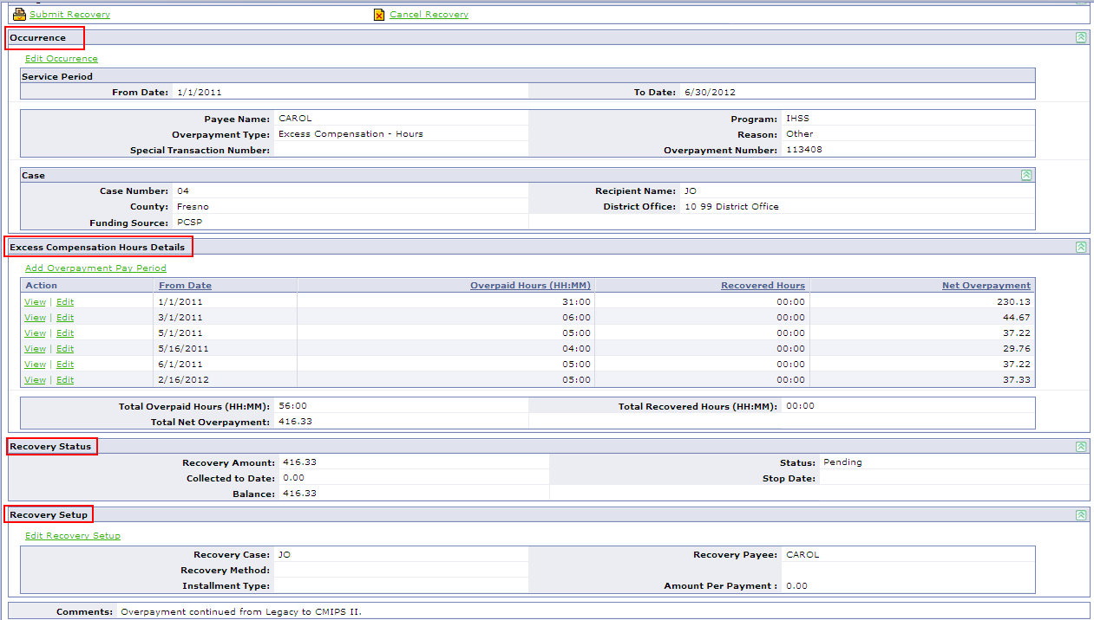
2
3
4
5
1
Manage Area Hyperlinks
- Submit Recovery-- To activate an OP recovery plan which is in a Pending status. The recovery set-up information is sent to Payroll for processing. For payroll deduction, the status is updated from Pending to Pending Payroll. For personal payment, the status is updated from Pending to Active.
- Cancel Recovery--To cancel the overpayment plan which is in a Pending or Pending Payroll status.
- Stop Collection-- To stop an active overpayment collection regardless of a remaining balance.

Note: If the overpayment occurred on a case not associated with the user’s county location, a notification is sent to the case owner when recovery has been submitted, cancelled or stopped.
2
Occurrence
This area is displayed for all overpayment types. Once the occurrence is saved from the Create Overpayment screen, the ‘Reason’ field is the only field you can modify. If an OP occurrence is created in error or is incorrect, it should be cancelled or closed. A new occurrence should be created.
3
Excess Compensation Hours Details
Identifies the specific pay period(s) and hours overpaid which supports the time span specified in Occurrence section. The default sort for this section is by user entry. However, columns can be resorted by clicking on the column title. System calculates the total net overpayment based on hours and rate information and tracks the hours recovered.
The Total Net Overpayment is calculated as:
Gross amount – (Federal income tax + State income tax + FICA + Medicare + SDI+ additional taxes) – Share of Cost
– (Lien + Health + Dues)

Once an overpayment pay period is created, it cannot be deleted but time entries can be modified to equal ‘zero’. If the overpayment spanned multiple months, the hours will be reinstated starting with the earliest overpaid month and working forward until the recovery is stopped or closed.

Recovery Status
4
This area is displayed for all overpayment types and identifies the Recovery Amount (OP amount), amount collected and overpayment status. The ‘Recovery Amount’ may be adjusted by county workers to reflect an amount less than the system calculated total net overpayment when the recovery status is Pending or Pending Payroll.

Note: The overpayment status of ‘Unavailable’ is designated only for payroll deductions for Advance Payment – Recipient overpayment type. For additional information, refer to work around #550.

Recovery Setup
5
This area is displayed for all overpayment types and identifies the recovery payee (person who incurred the OP), case for which the overpayment is collected against, method of collection and payment amount to collect.

Note: If the recovery payee becomes inactive in CMIPS II and an outstanding balance exists, do not stop the overpayment recovery plan unless the recovery payee will not be reinstated in the future (i.e. death). This allows the recovery plan to be updated to re-start collection from the recovery payee on the new IHSS case. Otherwise, a new overpayment occurrence needs to be created for the remaining balance including all supporting details in order to start the collection again.

Before Starting, the check list will assist in gathering the necessary information to set up your overpayment occurrence:
- Recovery Payee: The person who incurred the overpayment
- Overpaid Hours: The specific hours overpaid per day per pay period or the total number of hours overpaid per pay period
- Overpaid service period ‘From Date’ and ‘To Date’. The ‘From Date’ cannot prior to the CMIPS II start date (1/2007). Note: A payment must exist in CMIPS II for the service period entered.
- Occurrence Case: The case from which the overpayment occurred
- Recovery Case: The case from which the overpayment is to be collected
- In a chronological order, group service period(s) by FFP source and district office

Note: If the OP spans multiple FFP source or the case is transferred to multiple district offices then different overpayment occurrence must be created for each change.

Note: A maximum of five (5) overpayment recoveries (with a status of Pending, Pending Payroll or Active) can be submitted per recipient/provider relationship.

What To Do
- After searching for the occurrence case, navigate to Payroll folder and open the Adjustment Actions folder. Select the Overpayment Recoveries link.

- From the Overpayment Recoveries screen, search for the pay period in which your overpayment occurred to prevent the creation of duplicate overpayment occurrences. The default display for this screen lists pending and active recoveries.

Note: Search criteria entered are limited to six months.

Stop; if your overpayment occurrence exists and is in active or pending status. Do not create another overpayment occurrence.

Continue; if your overpayment occurrence is not listed or reflects the status of Cancelled, Closed or Stopped.

- From the Overpayment Recoveries screen, select the New link to create a new overpayment occurrence.

- From the Create Overpayment Occurrence screen, complete the following fields. Then, verify all information is accurate then select the Save link.
Field Name | User Action
Service Period From Date | Enter the begin date of the first pay period in which the overpayment occurred
Service Period To Date | Enter the end date of the last pay period in which the overpayment occurred
Payee Name | Search for and select the person who incurred the overpayment
Program | Select the IHSS
Overpayment Type | Select Excess Compensation - Hours
Reason | Select from drop-down list the reason the overpayment occurred.
Special Transaction Number | N/A
Comments | Enter information about the overpayment. Up to 200 characters can be entered.

Note: Once the occurrence information is saved and it is determined the information was entered erroneously, the overpayment occurrence needs to be cancelled or stopped and a new occurrence should be created.

- From View Overpayment Recovery screen, set-up the method of recovery by selecting the Add Overpayment Pay Period link and complete the following fields.

Field Name | User Action
Pay Period From Date | Enter the starting date of the service period for which the overpayment occurred.
Payee Name | Verify name of the person who incurred the overpayment.
Program | IHSS
Time Entries  01 – 15 OR 16 – 28 OR  16 – 29 OR 16 – 30 OR  16 – 31 | Enter the HH:MM overpaid.  Note: If a value is entered in the Minutes field exceeds 59, CMIPS II will convert it to the correct HH:MM format.  Caution: Although time entries greater than 24-hours is allowed, hours entered per pay period should not exceed the Authorized to Purchase hours for that pay period month.

- If overpayment occurrence spans multiple pay periods, repeat step 5 to enter the supporting details for each pay period.

- From View Overpayment Recovery screen, review the Recovery Status section. Determine if the recovery amount should be adjusted to reflect a negotiated amount less than the system calculated recovery amount.

- In the Recovery Setup section on the View Overpayment Recovery screen, select the Edit Recovery Setup to create the recovery collection plan by completing the following fields:

Field Name | Help
Recovery Amount | The amount to be recovered.  Note: If adjusting, ensure the amount entered is less than the displayed system calculated amount.
Recovery Case | Select the case from which the overpayment should be collected.
Recovery Payee | Verify the name of the person who incurred the overpayment.
Recovery Method | Select method:  Payroll deduction or Personal payment
Installment Type | Select type of installment to be taken:  - Percentage – 5%  - Percentage – 10%  - Negotiated  - Other
Amount Per Payment | For Installment Types of Negotiated and Other, an entry in this field is required.
Comments | Review and enter additional information about the overpayment. Up to 200 characters can be entered.

- From View Overpayment Recovery screen, review the entire recovery plan for accuracy. Then, select the Submit Recovery link to activate the OP recovery plan.

Note: The recovery set-up information is sent to Payroll for processing. For payroll deduction, the status is updated from Pending to Pending Payroll. For personal payment, the status is updated from Pending to Active.

Create Overpayment Occurrence-Legacy Special Transaction
Dollar-based overpayments are limited to the following OP types: Restaurant Meals, Share of Cost, Special Transaction, Converted Overpayment and Legacy Special Transaction. If the OP did not occur in CMIPS II and is not a converted OP. The Legacy Special Transaction can be used to setup the OP occurrence to collect the dollar-based amount. This will allow you to enter the recovery amount.

What To Do
- After searching for the occurrence case, navigate to Payroll folder and open the Adjustment Actions folder. Select the Overpayment Recoveries link.

- From the Overpayment Recoveries screen, select the New link to create a new overpayment occurrence. Complete the following fields:

Field Name | User Action
Service Period From Date | Enter the begin date of the first pay period in which the overpayment occurred
Service Period To Date | Enter the end date of the last pay period in which the overpayment occurred
Payee Name | Search for and select the recipient or provider who incurred the overpayment
Program | Select the IHSS
Overpayment Type | Select Legacy Special Transaction
Reason | Select from drop-down list the reason the overpayment occurred.
Special Transaction Number | N/A – Only required for CMIPS II issued spec trans.
Comments | Enter any additional information about the overpayment.  Up to 200 characters can be entered.

- From View Overpayment Recovery screen, select the Edit Recovery Setup link. Then, complete the Modify Overpayment Recovery Setup Screen. This is where you will enter the dollar-based amount along with other necessary information.

- From View Overpayment Recovery screen, review the entire recovery plan for accuracy. Then, select the Submit Recovery link to activate the OP recovery plan.

Overpayment from Legacy Cannot be established in CMIPS II
During the conversion process, Legacy warrants that cannot be tied to Eligibility Segments were not converted into CMIPS II. If an OP occurred on these Legacy warrants, counties cannot create an OP occurrence in CMIPS II.

CDSS/OSI has approved a process as to how to record overpayment collections in CMIPS II when the error message “Payee did not receive any payments for the selected Program during the selected Service Period Range” is encountered incorrectly. Steps below support the instructions provided with Overpayment Collections through Journal Voucher Adjustment (JVA) process flow.
- When a user receives the error message “Payee did not receive any payments for the selected Program during the selected Service Period Range” AND the user has confirmed that payments do indeed exist in the Legacy system, then the county must request that the provider send payment(s) directly to the county.

- Once the County receives a payment, the user should:
- Record/key overpayment information in the Provider (or Case) Notes screen in CMIPS II. Refer to the ‘Overpayment Information’ word doc to identify what information should be recorded.
- Open an SR (or respond to SR if already open) and include same information recorded on the Provider (or Case) Notes screen.

- Help Desk will assign SR to level 3 HP Back Office and request the following:
- Record payment through a JVA transaction.
- Update SR with JVA # and send SR back to Help Desk.

- Help Desk will relay to end user to update provider notes with SR# and JVA#.

- At this point the SR for this payment collection can be closed.

NOTE: For issues like this, the SR will serve to track the first collection received from the provider (or recipient). A separate SR must be opened EACH time a collection is made and the same steps from above should be followed.

Overpayment Collections through Journal Voucher Adjustment (JVA) process flow
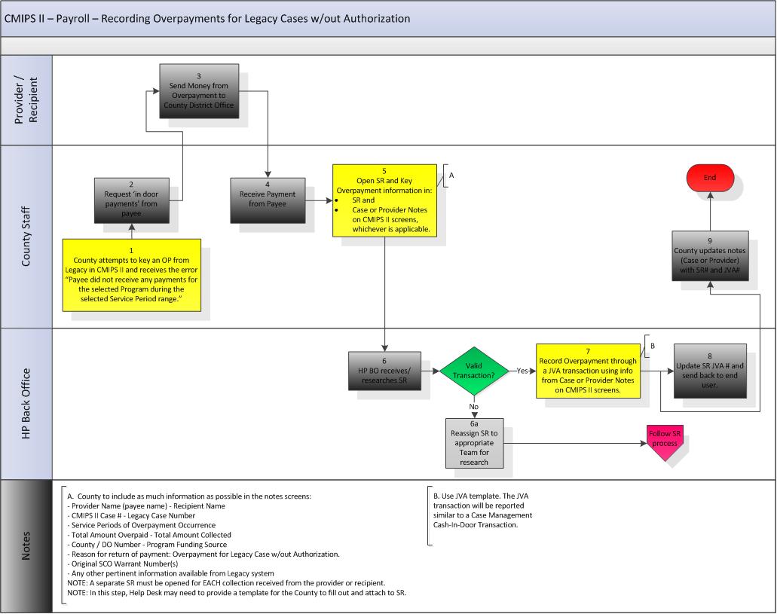

Recording Overpayment On Legacy Case or Provider Record Not Converted

During the conversion process, Legacy cases or provider records that did not meet the conversion threshold of 5.5 years were not converted to CMIPS II. When an overpayment is collected for the non-converted Legacy case or provider record, an SR should be submitted to the HP Help Desk who will assign it to the HP Back Office. The HP Back Office will record the overpayment and its collections through a JVA transaction similarly to the Overpayment Collections through Journal Voucher Adjustment (JVA) process flow.

What To Do

- When the county receives a payment and has confirmed the case or provider record does not exist in CMIPS II but does indeed exist in the Legacy system, the user should:

Note: Do not create a new case or provider record in CMIPS II. An overpayment cannot be created when payment records do not exists.

  - Open an SR (or respond to SR if already open) and include the following information

SR Detail | Description
Overpayment Recovery Information
County / District Office | County / District Office from where the overpayment originated
Funding Source | Funding Source at the time the OP occurred
Legacy Case # | Legacy case from which the overpayment occurred
Legacy Provider #  (if applicable) | Legacy number assigned to the provider who incurred the OP
Payee Name | The name of the recipient or provider identified on the warrant
Original SCO Warrant(s)  (if available) | Optional: This information assists the HP Back Office in verifying the request but is not required to process the overpayment.
Overpayment Recovery Amount | Total overpayment amount
Reason for Overpayment (if available) | Optional: The cause of overpayment
Collection Information
Collection Date | The date the county received the payment
Amount Collected | The dollar amount collected
Other Pertinent Information | Any additional information about the overpayment in Legacy (i.e. type of collection, check or money order number, bank reason for rejecting and returning the warrant, etc.)

- (optional) For the county’s record, user may print the SR detail information to file it in the case folder.
DO NOT mail the collected payment to HP.

- Help Desk will assign SR to level 3 HP Back Office and request the following:
  - Record payment through a JVA transaction.
  - Update SR with JVA # and send SR back to Help Desk.

- Help Desk will relay to end user to update the case file with SR# and JVA#.
- At this point the SR for this payment collection can be closed.

NOTE: The SR will serve to track the first collection received from the provider (or recipient). A separate SR must be opened EACH time a collection is made and the same steps from above should be followed.

Special Transaction-State Hearing: Authorize Pay Prior To Application Date
CMIPS II allows back dating the IHSS Referral/Application Date up to two (2) weeks only. This action can only be taken during the initial case creation process on the Create Case screen or the reactivation process on the Reactivate Case screen.

If an Administrative Hearing is filed and the hearing outcome orders the county to issue payment retrospectively for a time frame prior to the CMIPS II IHSS application date, a special transaction should be created to comply with the hearing outcome.

What to Do

Special Transaction for State Hearing

- Before payment can be issued, verify the case owner has created and activated the State Hearing assessment as specified in the hearing outcome.
- Then, payroll staff will need to manually calculate one of the following:
  - The amount owed to the recipient. This calculated amount needs to include payment back to the date specified in the hearing outcome because the CMIPS II application date cannot be updated.
For example:
Hearing outcome requires services to be paid back to 8/2/2012 but the CMIPS II application date is 9/2/2012. The manual calculation amount needs include payment back from 8/2/2012 - 9/1/2012. Then, on the Create Special Transaction screen the service period entered should be from 9/1/2012-9/15/2012.

OR

  - The hours owed to the recipient. This calculated time needs to include hours back to the date specified in the hearing outcome because the CMIPS II application date cannot be updated.
  - Determine if the county pay rate is applicable for the time-frame specified in the hearing outcome.

- From CMIPS II, navigate to the Special Transaction screen and select New link to create a special transaction.
- From the Create Special Transaction screen, enter the following:

Field Name | Data Entry
Service Period From Date | The 1st day of the pay period for which the case is in Eligible status in CMIPS II
Service Period To Date | The last day of the pay period for which the case is in Eligible status in CMIPS II
Payee Name | Recipient’s name
Program | IHSS
Type | State Hearing Decision
Amount | The manually calculated amount from step 2a.
Hours (HH:MM) | Enter the manually calculated time owed from step 2b.
Rate Override | If applicable, enter the rate from step 2c. Otherwise, no change.
Comments  (Limit is 200 characters) | State Hearing Payment Transaction dated xx/xx/xx in the amount of $XX.XX represents $XX.XX times XX hours covering “Enter Date Here” period to comply with State Hearing Decision dated xx/xx/xx.

Reports: Functionality Clarification

Reports In County Folder
In Reporting, a new County folder has been created within Public Folders. Each county will have their own folder where users may access and view batch reports. The below chart illustrates when batch reports will be generated and placed in the County folders.

Frequency | Description
Daily | Daily batch reports are run each business morning (between 3:00am and 5:00am).  Note: If there is a delay in the batch process, reports may show up later than the specified time frame.
Weekly | Weekly batch reports are generally scheduled to run each Friday after the daily reports complete.
Monthly | Monthly batch reports are scheduled to run after midnight on the last day of each month and will be available the next business day.  In some situations (i.e. a wave conversion), the Monthly reports could be scheduled to run on the weekend following the last day of the month or a different date (*).
Quarterly & Annual | Quarterly and annual batch reports will be available the first Monday following the end of each quarter or year.
Interface Triggered Reports | These reports are not scheduled for a particular weekly or monthly batch cycle but will run when the interface file is processed. For example County Contractor (CC), Health Benefits Manager (HBM) or Labor Organization (LO).

Below is a listing of all the batch reports and its version that will generate in a PDF format for the specified frequency. County users may continue to schedule their own report in a different version, and those successful executions will be placed in the user’s In-box.

Daily Batch
Report Name | Version
County Contractor Journal Voucher | County
County Payment Voucher | County
County Payment Voucher - Advance Pay | County
Homemaker Journal Voucher | County
Meds Alerts Caseload Detail | County
Meds Alerts Caseload Summary | County
Overdue Assessment Listing | County
Payment Voucher Summary | County
Payment Voucher Summary - Advance Pay | County
Request For Void Stop Payment | County
Timesheet Statistics Tracking | County
Warrant Redeposit Listing - Vendor | County
Warrant Redeposit Summary | County
Warrant Redeposit Summary - Vendor | County
Provider SSN And Enrollment Status Report | County
Weekly Batch
Report Name | Version
Timesheet Statistics Tracking | County
Payment Voucher Summary | County
Payment Voucher Summary - Advance Pay | County
Warrant Redeposit Summary | County
Warrant Redeposit Summary - Vendor | County
Timesheet Exception Report | County
Monthly Batch
Report Name | Version
Active Caseload Report | County
Application- Approval-Denial-Termination Listing | County
Application- Approval-Denial-Termination Listing - Summary | County
Authorized Case Summary And Detail | County
Case Actions Overview Report | County
Caseload Growth Report | County
Caseload Summary | County
Disenrolled Provider - No Timesheet Activity Report | County
Histogram Of Records Awaiting Online Archive By Quarter | County*
Homemaker Caseload Characteristics Listing | County
Homemaker Detail & Summary Time | County
Hourly Task Guideline Report | County
Hourly Task Guideline Report(County Level) | County
IHSS Plus Option Annual Report | County
IHSS Plus Option Monthly Data Report | County
In-Patient Hospitalization Report | County
In-Patient Hospitalization Report(County) | County
Monthly Assessment Due Report | County
Monthly Caseload, Hours Paid And Expenditures - Total Report | County
Monthly Change To Primary Medi-Cal Aid Code Report | County
Monthly Inter-County Transfer Case Status Report | County
Monthly Investigation Referrals Activity Report | County
Monthly Leave Status Report-P | County
Monthly Leave Status Report-R | County
Monthly Medi-Cal RV Due | County
No Timesheet Activity For 60 Days Provider Report | County
No Timesheet Activity For 60 Days Social Worker Report | County
Out Of State Provider Payment Report | County
Overpayment Status Report | County
PA Providers Report | County
Paid Case Summary And Detail | County
Potential Variable Assessment | County
Provider Hours Over 300 Paid Report | County
Purge Statistics And Records | County*
Purged Records | County*
QA Assessment Review | County
Reason Code Report | County
Reassessment Summary Report | County
Recipient Summary Characteristics Listing | County
Refused Services Detail Report | County
Refused Services Summary Report | County
Residual Caseload 2N Report | County
SCO Death Match Response Report | County
Service Assessment Summary | County
SOC COLA Exceptions Report | County
Special Transaction Summary Report | County
State Hearings Request Report | County
Timesheet Statistics Tracking | County
Warrants Issued Report | County
Benefits Deductions Reconciliation | County*
County Contractor Payment | County
Discontinuance From IHSS Eligibility By Reason | County
Homemaker Payment | County
Intake Tracking Report | County
Labor Org Deductions Not Taken | County*
Labor Org Deductions Reconciliation | County*
Monthly Renewal Exception Report | County
Monthly Renewal Exception Report - State Summary | County
Monthly Rescinded Termination Listing Report | County
Payment Voucher Summary | County
Payment Voucher Summary - Advance Pay | County
Reconciliation Of Advance Payments | County
Quarterly Reports
Report Name | Version
Caseload Growth Report | County
Out Of State Provider Payment Report | County
Referrals By Source By County | County
Unannounced Home Visit Quarterly Report | County
Unannounced Home Visit Statewide Summary | County
Payment Voucher Summary | County
Payment Voucher Summary - Advance Pay | County

Monthly Assessment Due Report

The Monthly Assessment Due Report provides social workers and their supervisors with a list of the status of all active cases (Eligible, Presumptive Eligible and Leave) that need reassessments in the current and two future months. Example: Current report run date is 04/01/13; the “reassessment due” that populate for this report are for assessments due in April 2013, May 2013 and June 2013.

The report provides recipient details. The assessment due date after conversion will be based on the Legacy “face to face” date thereafter and for new cases it will be based on the “reassessment due” date.

The Monthly Assessment Due Report does not provide a Summary of the Total assessments due in a given month. The information is now provided in the Reassessment Summary Report. The report will list both the total and the average number of assessments due each month per worker in a unit. The information is displayed per month for the entire year.

The report no longer lists the Recipient SSN. New additions to the report are funding source, protective supervision indicators, companion cases, paramedical and the recipient’s spoken language

A version of this report will be generated automatically as part of the monthly batch process. Once generated, counties may view this report by accessing their own county specific folder located in the ‘County’ folder within Public Folders. For details, refer to the Reports in County Folder section.

Counties may also continue to schedule their own report. This report requires date parameters. When scheduling, do not use the automated recurring features in Reporting. Refer to the CMIPS II training material, Module 14, Schedule a Report in Advance section to schedule this report individually.

Nice to Know

Crystal Report provides a drop down/ “tree” on the left navigation that list the County. When that entry is expanded it will display a list of the supervisors/units in the office. Expanding a unit will display a list of the workers in the unit. As an individual file/worker is expanded it will display a list of that worker’s cases that are due for reassessments by due date for the first month followed by 2 consecutive months.

Adobe Acrobat version will have the entire D.O.’s assessments due in a 3 month period. It will list all in alphabetical order by recipient’s last name. The Adobe Acrobat has a feature that allows a data search by worker’s file number.

Monthly Caseload, Hours Paid and Expenditures - Total

The Monthly Caseload, Hours Paid and Expenditures – Total Report is a statewide summary report with a single row for each of the 58 counties. The report columns include:
• Total of All Modes
• Individual Provider (IP)
• County Contractor (CC)
• County Homemaker (HM)

The ALL COUNTIES row is a sum of the data reported for each county.

The information in this report was included in the Legacy Management Statistics Report.

The report total reflects an unduplicated count of all cases for which payments were made in the report month. This means that the report reflects all hours and the resulting gross wages paid in any given month regardless of the pay period for which the payment was being made. [The report for January, 2013 generated after 01/31/13 will contain the same information regardless of whether it is generated a week, a month, or year later because it reflects what was done during that calendar month.]

The dollar amounts on the Monthly Caseload, Hours Paid and Expenditures Report are the Sum total of the gross wage expense amount for cases with IP, CC and HM modes of service by county. This amount is unduplicated and will match the monthly total of the Payment Voucher report for gross wages generated daily.

Overdue Assessment Report
The Overdue Assessment Listing Report lists cases in Eligible, Presumptive Eligible or Leave status which have a Re-assessment Due Date in any month prior to the calendar month in which the report is run. However, a case is not considered overdue for an assessment until the month following the ‘Reassessment Due Date’. This means the worker has until the end of the reassessment month to activate the reassessment evidence in CMIPS II.

Once listed, the case will drop from the report the day after the reassessment evidence is activated. This is because the Reporting database is updated nightly with the prior day’s work.
Case Scenario
Reassessment Due Date: 01/15/2013
Beginning February 1st, case A is listed on the Overdue Assessment Listing report.
On 2/15/2013, the worker creates the reassessment evidence.
On 2/20/2013, the worker submits the reassessment for approval. The reassessment evidence is activated.

On 2/16/2013, the report is generated and case A is listed as overdue.
On 02/21/2013, the report is generated and case A is no longer listed as overdue.

The county version of this report is generated automatically as part of the daily batch process. Once generated, counties may view this report by accessing their own county specific folder located in the ‘County’ folder within Public Folders.

Counties may also continue to scheduling their own report. This report requires date parameters. When scheduling, do not use the automated recurring features in Reporting. Refer to the CMIPS II training material, Module 14, Schedule a Report in Advance section to schedule this report individually.

Conversion Impacts:
Counties will need to keep the final Legacy Overdue Assessment and utilize it in conjunction with the first CMIPS II version of the report for working reassessments, and then in the second month of CMIPS II the Overdue Assessment report will be comprehensive.

- Month prior to Go-Live (GL): Legacy Overdue Assessment Report will list all of the overdue cases.

- Month of Go-Live: Anything due in GL month will show on CMIPS II Overdue Assessment Report. If a case was due the month prior to GL and the reassessment wasn't completed (in month prior to GL nor in month of GL), it will not show up on the report this month but will show up next month. In other words, Month of GL report will be significantly smaller than expected due to the extensions built in during conversion.

- Month after Go-Live: All cases overdue will now show on CMIPS II Overdue Assessment Report.

Nice To Know
The detail version of the report no longer provides recipient SSN, aid code and total number of cases by status (Eligible, Presumptive Eligible or Leave). New additions to the report are recipient CIN, companion case identifier, fund source (2L, 2M, & 2N), total overdue reassessments for the worker and total overdue reassessments for the supervisor.

The summary versions of the report do not provide a historical listing of total cases due for an assessment in the past 12 months. To obtain trending information, counties should retain the report in a PDF format for each month. The District Office version is new and counts the number of cases with an overdue assessment by supervisor. How each county’s organization is set up in CMIPS II impacts how Reporting reflects the summary data.

Example: County A’s organizational structure has 1 supervisor per district office.
For this example, there will be multiple pages reflecting 1 supervisor per district office per page when the District Office version is generated. When obtaining a summary, the County Summary version is recommended and would quickly provide the total for each district office (which equates to each supervisor in this example).

Provider Payment Summary Report and Detail Report

The Provider Payment Summary report provides the county/state staff with a provider’s payment summary. The report can be run at any time, and will return payment data for the provider number for which it is run for a specified date range.

Unlike the Provider Payment Detail Report, the Provider Payment Summary report does not display detailed information about a specific warrant, but all warrants for an individual provider during a specified service period. For example, the report can be run for the service period of 7/1/2012 to 7/31/2012 for provider Mary Smith. It will display any payments for that time period and the payment status (cleared, paid, pending void, void and pending replacement) along with other details.

If the user schedules the report with the Provider Number and the date range for which information is needed, the report will be available in the user’s Inbox.

NOTE: The Provider Payment Detail Report is accessed from the Provider Payment Summary Report by selecting the warrant number which is a link to the details of the warrant.

Provider Payment Detail Report

The Provider Payment Detail Report provides the county/state staff with a provider’s payment details for a specific warrant. The report is accessible by selecting the Warrant Number link on the Provider Payment Summary Report.

When setting up the parameters for this report for format parameter select "Crystal Reports", if you choose Adobe Acrobat the Warrant number will show as hyperlink but when you select it, it will not open anything; yet the Crystal Reports format will allow you to select the hyperlink and the warrant details screen will open.
The Provider Payment Detail Report differs from the Provider YTD History Report in that the Provider YTD History Report displays all recipients for whom the provider worked and the associated payments made YTD. The Provider Payment Detail displays detailed information about a specific warrant received by the provider for a specific recipient. It is differentiated from the Provider Payment Summary because it lists all of the deductions in detail such as liens, pay adjustments, taxes, health benefits, labor organization dues. It can be used to assist a provider who inquires about specific deductions taken from a warrant and is likely to be used by payroll staff.

Timesheet Exception Report

The Timesheet Exception Report lists recipients and providers where an exception was encountered during the validation of their timesheet at TPF. The report is sorted alphabetically by Exception Type, then by Worker #. The report is inclusive of hard and soft timesheet exception edits. A hard edit exception record will remain on this report until the pay period following the resolution. A hard edit exception prevents payroll processing, including Holds. Soft edit exception records will display on this report for the reporting period only (cycle date) as they do not need resolution and do not prevent payroll processing. If the timesheets is manually entered in CMIPS II and an exception is encountered, it will not be displayed on this report; county worker should resolve issues at the time of entry.

Example:
If a timesheet comes in on 05/02/2009 with a hard edit exception and this hard edit exception is not resolved until 06/02/2009, the timesheet exception will appear on the May reports and the first pay period June report. If a timesheet comes in on 05/02/2009 with a soft edit exception, this soft edit exception will appear on the May report only.

There are two versions of this report: Timesheet Exception Report – IHSS Report and Timesheet Exception Report – WPCS Report. The county version of this report is generated automatically as part of the weekly batch process. Once generated, counties may view this report by accessing their own county specific folder located in the ‘County’ folder within Public Folders.

Counties may also continue to scheduling their own report. This report requires date parameters. When scheduling, do not use the automated recurring features in Reporting. Refer to your CMIPS II training material, Module 14, Schedule a Report in Advance section to schedule this report individually.

Field Description
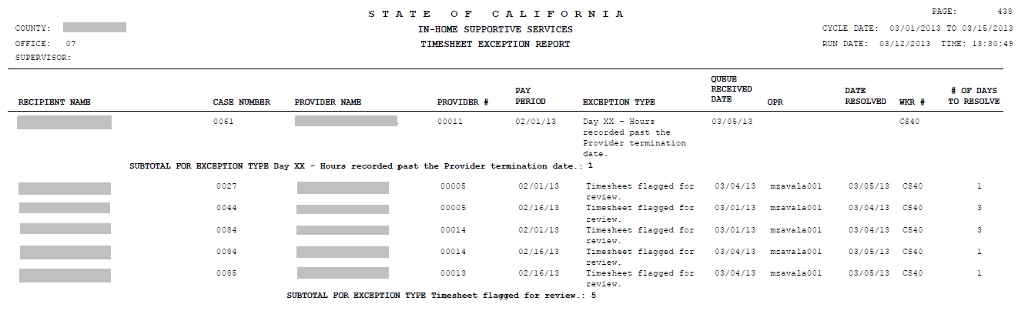

*Field | Description
Pay Period | The first day, MM/DD/YY format, of the actual pay period from the submitted timesheet. The only days that will populate here are the 1st or 16th of the pay period.
Exception Type | Description of the exception. For exception types that note ‘Day XX’, the XX will not be populated with a specific day. Multiple instances of the same error can occur on different days on the same timesheet but will only display once on this report.
Queue Received Date | The date CMIPS II sent the exception to the county work queue or the date CMIPS II identified the soft edit exception, in MM/DD/YY format.
Opr | CMIPS II user (social worker, payroll analyst, etc) who resolved the hard edit.
Date Resolved | The date, MM/DD/YY format, the hard edit is manually cleared or system cleared.
Wkr # | The social worker’s number associated with the recipient’s case.
# Of Days To Resolve | The elapsed time, in Days, between the Date Resolved and the Queue Received Date.
Subtotal For Exception Type | The subtotal of recipients/providers receiving the specified error message.
*Not all fields on the report are listed.

Other Information

How To Multi-Task Within Case Management

When you need to exit the current screen you are in to perform a quick search or quick update to the case/person record but have to navigate back to continue your data entry, a second instance of CMIPS II can be opened by following the instructions below.
- From your current screen, identify and place your cursor on the folder or hyperlink you want to navigate to. Using your mouse, right-click on the folder or hyperlink to open a pop-up window.

- From the pop-up window, select Open in New Window.

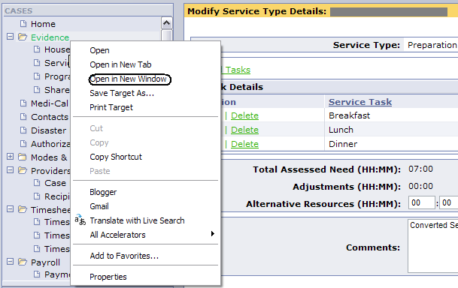

- A second instance of Case Management opens displaying your selected screen (i.e. Case Home screen). Similarly to the 1st instance, you may navigate or update case information within the 2nd instance.

- When you are done with the 2nd instance, it is important to close it to prevent confusion.

To Get Rid Of Security Warning Pop-Up Window

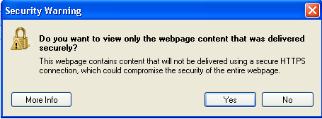
What To Do

- When in Internet Explorer, select TOOLS from the top menu

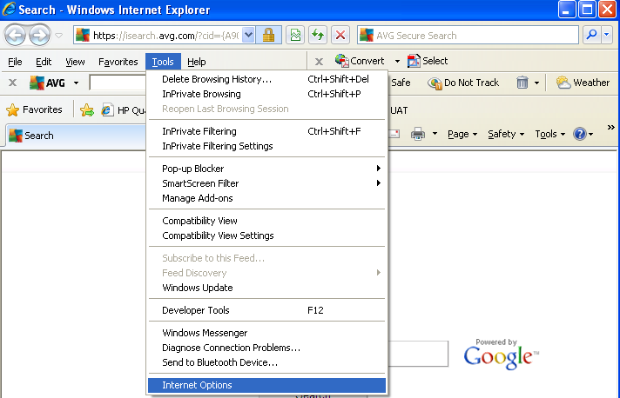
- Select INTERNET OPTIONS from the drop-down menu
- Select SECURITY tab
- Select CUSTOM LEVEL button
- Scroll down almost half way to MISCELLANEOUS section
- Find DISPLAY MIXED CONTENT and select ENABLE
- Click OK until out of menu

